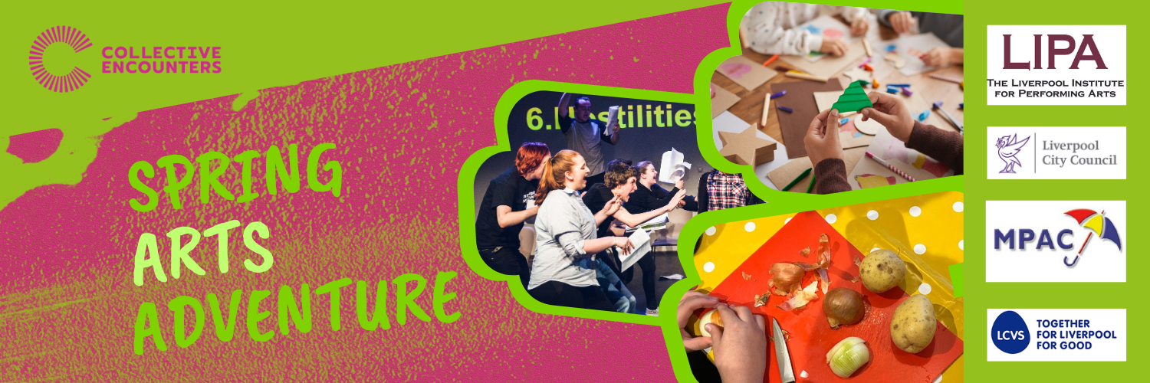

Please fill in your details below to confirm your booking
In order to stay in touch, improve what we do and report to stakeholders we need you to provide some basic details. We will never sell data and we promise to keep your details safe and secure. You can change your mind at any time by emailing eleanor@collective-encounters.org.uk
For further information on how your data is used and stored visit here: https://collective-encounters.org.uk/policies/privacy-policy/

Please return your completed booking form to eleanor@collective-encounters.org.uk

You can attend all four days or select which day you would like to attend. Please let us know which days you will be joining us:
Day 1 - Monday 31st March
Day 2 - Tuesday 1st April
Day 3 - Wednesday 2nd April
Day 4 - Thursday 3rd April
Please let us know which local authority the young person is with:

Liverpool
Sefton
Wirral
Knowsley
Personal details

Name of young person:

DOB of young person:

Preferred pronouns:
i.e. She/her – He/Him – They/Them

Current Postcode:

School:

Do they receive free school meals?

Details of any allergies:

Any medical conditions we need to know about:

Any dietary requirements or food preferences:

Access requirements or special educational needs- please tell us anything we need to know to enable the young person to get the most out of the activities:

Name of carer/ main contact:

Email address of carer/main contact:

Phone number of carer/ main contact:

Name of secondary emergency contact:

Phone number for second emergency contact:

Travel arrangements- please let us know how the young person will be travelling to and from the activities each day. If they are being collected, please tell us who will be collecting them:

Is there anything else we need to know?

Equality, diversity and inclusion monitoring

This information helps us to monitor who is taking part in our projects. Please fill in as much as you feel comfortable with. This whole section is optional.

Is the young person eligible for benefits-related free school meals? (this is for monitoring purposes only and will not affect eligibility. Please delete as appropriate.)

YES/NO

How do you (young person) identify? Please select all that apply:

- Female
- Male
- Non-binary
- Gender is different to the one assigned at birth
- D/deaf or disabled
- I live with a long-term health condition (physical health or mental health)
- I am neurodiverse
- I have caring responsibilities
- Working class
- Working class/ Lower middle class
- Middle class
- Upper/middle class
- Asylum Seeker
- Refugee
- Other

How would you describe your ethnicity?

Experience

Which of the following best describes you:

- I never engage with Arts and Culture
- I rarely engage with Arts and Culture
- I sometimes engage with Arts and Culture
- I regularly engage with Arts and Culture

Photos and Videos

Collective Encounters takes photographs & films during workshops and performances. This is for the purpose of providing evidence for Arts Award portfolios, and images will not be shared publicly. Young people may request copies of photos and videos that they are in, on the condition that they do not share them online. Please indicate that you agree with the following statement:

“I give permission for Collective Encounters to film and photograph _____________ (young person's name) in workshops and performances. I understand that these films and photographs will be used for evidence portfolios where accredited training is taking place, and that young people may request copies of films and photographs they are in. No images will be shared online.”

Yes No

