Our Lady Immaculate Catholic Primary School

Relationship, Behaviour and Belonging Policy
To be read alongside: Anti-Bullying, Safeguarding (KCSIE), Care and Control, SEND, Equality and Accessibility policies.

1. Policy Rationale and Ethos
At Our Lady Immaculate Catholic Primary School, we are one family living and learning together in faith. Our approach to relationships, behaviour and belonging is rooted in Gospel values, Catholic Social Teaching and respect for the dignity of every person. This policy promotes positive relationships, personal responsibility and restorative practice, while setting clear expectations and predictable consequences to ensure the safety, wellbeing and learning of all.
At Our Lady Immaculate Catholic Primary School, we believe that positive behaviour grows from a strong sense of belonging. Every child is known, loved and valued as a unique child of God and has the right to feel safe, valued and included within our school community. A strong sense of belonging is central to positive behaviour, healthy relationships and effective learning.
We understand that behaviour is a form of communication and that pupils are more likely to flourish academically, socially and emotionally when they feel safe, accepted and included. When children feel connected, supported and respected they have a greater chance of achieving academic excellence. Our approach to behaviour is therefore rooted in relationships, fairness and restoration.
Belonging sits at the heart of our ethos. When children feel valued, connected and noticed, they thrive socially, emotionally and academically. We embrace the principle expressed by Mark Finnis: "Children don’t behave their way into belonging; they belong their way into behaving." Belonging is not earned—every child has the right to feel part of our school family. A strong sense of belonging provides the foundation for positive behaviour and successful learning.
Belonging at Our Lady Immaculate means:
- Feeling safe, respected and listened to
- Knowing that differences are celebrated and everyone is valued
- Experiencing fairness, forgiveness and reconciliation
- Being supported to develop positive relationships with others

Promoting Belonging
We actively promote a sense of belonging by:
- Creating a warm, caring and inclusive school environment
- Teaching children to recognise their responsibility to one another, in line with Catholic values
- Encouraging kindness, empathy and cooperation in all interactions
- Using restorative approaches to resolve conflict and repair relationships
- Ensuring that behaviour expectations are clear, consistent and fair
- Providing targeted support for pupils who may feel vulnerable, excluded or disconnected

2. Behaviour Expectations and Belonging
Clear and consistent behaviour expectations are in place to ensure that all members of the school community can learn and thrive. These expectations are taught explicitly, modelled by adults and reinforced positively.
When behaviour falls short of expectations, staff respond in ways that:
- Maintain the dignity of the child
- Reinforce that the child still belongs to the school community
- Help pupils understand the impact of their actions on others
- Support pupils to take responsibility and make better choices
Consequences are used to help children reflect, learn and repair, not to exclude or shame. Where appropriate, consequences are proportionate, predictable and clearly linked to the behaviour, ensuring fairness and consistency across the school.

3. Our Shared Values and Code of Conduct
We expect all members of our community—children, staff, parents and visitors—to act with respect and care. We:
- Respect ourselves, others and our school
- Work hard and persevere; do our best and never give up
- Welcome others with kindness and a smile
- Recognise achievement and celebrate success
- Listen and show we care for one another

4. Restorative Practice
Restorative practice is central to our approach to behaviour and belonging. It supports children to rebuild relationships and develop empathy, accountability and self-regulation.
Restorative approaches may include:
- Supported conversations to reflect on:
  - What happened?
  - Who has been affected and how?
  - What needs to happen to make things right?
- Opportunities for pupils to apologise, repair harm and restore trust
- Adult modelling of forgiveness, reconciliation and respectful communication
Through restorative practice, children learn that mistakes are opportunities for growth and that reconciliation is possible when responsibility is taken.

5. Promoting Positive Relationships and Behaviour
We prioritise prevention, inclusion and restoration. Behaviour is understood as communication; support is adapted to individual needs, including SEND and SEMH. The school teaches behaviour explicitly and integrates it through the PSHE and safeguarding curriculum.
Key approaches include:
- Explicit teaching of behaviour expectations and classroom routines
- PSHE, Circle Time and safeguarding curriculum links
- Reflect, Repair, Rebuild restorative process
- Consistent use of agreed core strategies (Appendix 1)
- Targeted support and interventions (e.g., SEMH support, Inclusion HUB, MISP, therapeutic play, external agencies)

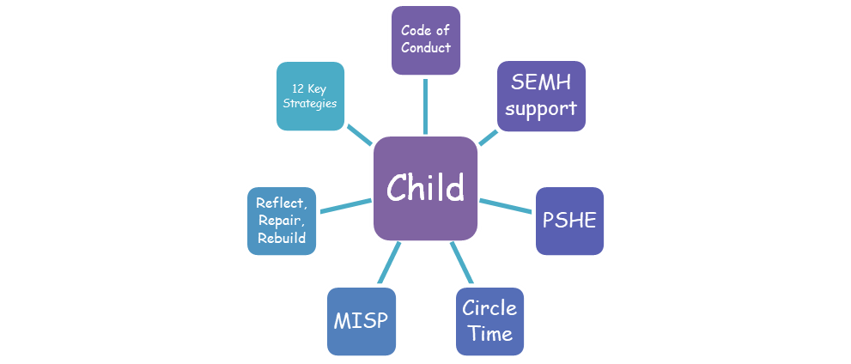

6. Recognition and Rewards
We praise, encourage and recognise children for considerate, positive behaviour in a variety of ways, for example:
- Verbal praise and positive feedback
- Stickers, Dojo points and class rewards
- Weekly celebration assemblies and certificates (shared with families)
- Social media posts celebrating achievements in and outside of school
- Recognition of achievements in and beyond school
Recognition reinforces belonging, motivation and self-worth and supports a safe, positive learning environment.

7. Managing Inappropriate Behaviour: Logical, Restorative Consequences
At Our Lady Immaculate, consequences are logical, educational and relational, never punitive. They are designed to help children learn, take responsibility and repair harm—supporting them to make better choices next time. Logical consequences directly relate to the behaviour, maintain dignity for the child and protect relationships. They always sit within the school’s restorative approach.
All responses to behaviour are calm, fair, proportionate and predictable, with a focus on understanding, reflecting and rebuilding. Consequences are not used to punish, shame or isolate; instead, they create opportunities for growth, accountability and reconnection.
When behaviour falls below expectations, staff will:
- Offer a timely reminder and support using agreed strategies
- Enable reflection to understand impact, feelings and unmet needs
- Guide the child to repair—putting things right in a meaningful way
- Rebuild—restoring relationships and returning to learning quickly
Where behaviour persists or requires additional intervention, leaders may implement logical consequences such as:
- Revisiting or redoing learning tasks that were avoided or completed without effort
- Restoring the environment, e.g., tidying a space or repairing something damaged where appropriate
- Apologising through action, such as a kind note or supportive gesture
- Loss of a privilege linked to the behaviour, e.g., if equipment was misused, the privilege of using it may be paused with adult support to relearn expectations
- Time given to regulate and reset, always with adult support and never used as punishment
- A Behaviour Support Plan for patterns of behaviour, with increased pastoral, SEMH or inclusion support
- Parental partnership, working together to support consistent routines and expectations
- Multiagency involvement where needs are complex or ongoing
Logical consequences should always:
- Be connected to the behaviour
- Be respectful, maintaining the child’s dignity
- Be reasonable and proportionate
- Be restorative, helping to rebuild relationships
- Focus on teaching the skills needed for success next time

8. Bullying, Harassment and Harmful Behaviour
Bullying, including child-on-child abuse, sexual violence or sexual harassment, is never tolerated. All incidents are responded to immediately and safeguarding procedures are followed in line with KCSIE. DSL oversight is maintained through CPOMS and each incident is assessed on a case-by-case basis.

9. Inclusion, Early support and Safeguarding
We recognise that some pupils may experience barriers to positive behaviour or developing a strong sense of belonging. Staff are vigilant in identifying early signs of disengagement, distress or unmet need.
At Our Lady Immaculate we:
- Use behaviour information to identify patterns and triggers
- Provide early intervention and targeted support
- Work closely with families and external agencies where appropriate
- Ensure that behaviour approaches are inclusive and supportive of pupils with additional needs
Our behaviour and belonging approach contributes directly to safeguarding by promoting emotional safety, strong relationships and clear boundaries.

10. Roles and Responsibilities
Staff will:
- Model positive relationships and behaviour
- Apply expectations consistently and fairly
- Record and report incidents accurately; maintain chronology
- Support pupils through restorative practice and agreed strategies
Headteacher will:
- Ensure consistent implementation of the policy
- Monitor behaviour data and trends; report to governors
- Support staff with standards and implementation
- Authorise suspensions and exclusions when necessary
Parents and Carers will:
- Work in partnership with the school and support the Code of Conduct
- Engage in dialogue when concerns arise and attend meetings
- Refer to the policy via the school website
Governors will:
- Approve and review the policy; monitor equality and fairness
- Scrutinise exclusions data and outcomes
- Support the headteacher and provide challenge where needed

11. Suspensions and Permanent Exclusions
We are an inclusive school and exclusion is a last resort within a graduated response. Prior to exclusion, the school implements Behaviour Support Plans and Positive Handling Plans as required and seeks support from external professionals. Only the headteacher may suspend or permanently exclude, in line with statutory guidance. Parents/carers, governors and the Local Authority are informed as required.

12. Prohibited Items and Searching, Screening and Confiscation
The following are not permitted on school premises:
- Knives or weapons
- Alcohol
- Illegal drugs and other harmful substances/solvents
- Stolen items
- Tobacco, vaping items and cigarette papers
- Fireworks
- Pornographic images
- Mobile phones and chewing gum
- Any article likely to be used to commit an offence, injure a person or damage property
Staff may search for prohibited items in line with DfE guidance on Searching, Screening and Confiscation (2022). Misuse or distribution of substances will result in serious consequences and may involve external agencies.

13. Recording, Monitoring and Review
- Serious incidents are recorded and monitored; DSL and senior leaders review patterns
- Data informs staff CPD and targeted support
- Headteacher reports to governors; safeguarding governor monitors
- Policy is reviewed biennially, or sooner if required

Appendices

Appendix 1: Agreed Core Strategies
State the Obvious | The Help Script | Choice Drivers | One Calm Voice
Partially Agree ("Yes, and…") | Tactically Ignore | Reflect, Repair, Rebuild | “Thanks”
The Help Protocol | Lead into Learning | Proximity Support / Change of Face | Personal Space

Appendix 2: Process for Post-Incident Debrief (Pupil)
Date: ____________ Incident Ref No: ____________ Staff: ____________ Pupil(s): ____________
Reflect – Use of story / social story / drawing / role-play etc.
Notes: ________________________________________________
Repair – Provide opportunity to “fix things up” / “do” sorry. Restore.
Notes: ________________________________________________
Rebuild – Strategies for “What can we do differently next time?” Links to learning.
Notes: ________________________________________________

Appendix 3: Positive Behaviour Support Plan (Template)
NAME: __________ DOB: __________ CLASS: __________ DATE OF PLAN: __________ REVIEW DATE: __________
ADDITIONAL INFORMATION:
KNOWN DYSREGULATORS / TRIGGERS:
DESCRIPTION OF CURRENT BEHAVIOURS CAUSING CONCERN (the child can…):
PREFERRED SUPPORTIVE STRATEGIES / RELATIONAL APPROACHES (Environmental / Teaching & Learning / Pro-social / Verbal / Non-verbal):
NEXT STEPS:
EVALUATION / Ongoing observations:
Headteacher/Deputy/SLT: | Date:
Parent/Carer: | Date:
Young Person: | Date:
Class Teacher: | Date:
Approved by the Governing Body: Spring 2026

