Our Lady Immaculate Catholic Primary School

HANDWRITING Policy & GUIDANCE FOR STAFF

Overview

In line with the primary curriculum statutory expectations, children must be taught to write with ease, speed and legibility. It is important that the child’s handwriting becomes a skill that ultimately requires limited use of their working memory so that creative and physical energy can be focused on the content of writing.
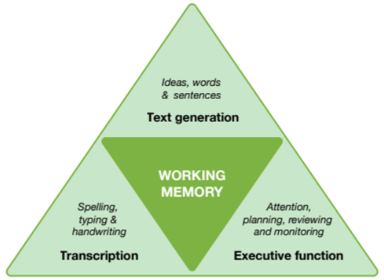

Aims & Objectives
Pupils will be taught to:
- Sit correctly at a table, holding a pencil comfortably and correctly using the tripod grip
- Begin to form lower-case letters in the correct direction, starting and finishing in the right place
- Form capital letters
- Form digits 0-9
- Understand which letters belong to which handwriting ‘families’ and to practice these.
- Be clear about what standard of handwriting is appropriate for a given task.

Fine & Gross Motor Practice
In line with school long term plan and curriculum overview, children are supported to make progress from fist palmar grip to digital pronate grip to four finger grip and finally to a tripod grip. This is done through a variety of gross and fine motor activities.
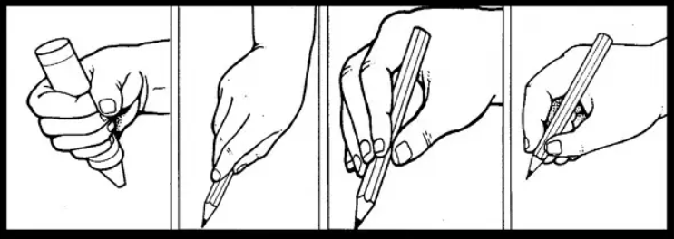
Fist Palmar Grip | Digital Pronate Grip | Four Finger Grip | Tripod Grip

Letter Formation

In Reception, the order of teaching the lower-case letter formation follows the Little Wandle phonics programme. As phonemes are introduced, children are taught the corresponding graphemes. Teachers will teach the ‘Little Wandle’ formation phrases and also make connections between letter families. Teachers will have very high expectations of accurate letter formation.

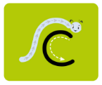
‘Curly Caterpillar’ letters:

c a d g q o s f e


‘One-armed robot’ letters:

r n m p b h k

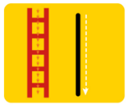
‘Long ladder’ letters:

i l t u j y

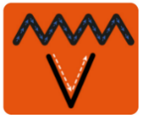
‘Zig-zag’ letters:

v w z x

Capital Letters

Children are taught that capital letters start from the top – that is, from just below the upper writing line. When writing a whole word which requires a capital letter at the beginning, a small space is left after the capital letter and the next letter starts on the line.

A B C D E F G H I J K L M N O P Q R S T U V W X Y Z

All upper-case letters are simple print letter shapes which do not join other letters.

Pre-Cursive Handwriting Style

When teachers judge that children have a correct and confident foundation of letter formation, children are taught to start using some of the diagonal and horizontal strokes needed to join letters, including pre-cursive join in line with ‘LetterJoin’ scheme.



The ‘LetterJoin’ scheme will be used to ensure the order of teaching the lower-case letter shapes is as follows:
‘Curly Caterpillar’ letters:
c a d g q o s f e
‘One-armed robot’ letters:
r n m p b h k
‘Long ladder’ letters:
i l t u j y
‘Zig-zag’ letters:
v w z x
Cursive Handwriting Style

Children are taught through ‘LetterJoin’ the two correct joins in cursive handwriting and are taught how to increase the legibility, consistency and quality of their handwriting.

Children are taught that capital letters start from the top – that is, from just below the upper writing line. When writing a whole word which requires a capital letter at the beginning, a small space is left after the capital letter and the next letter starts on the line.

All upper-case letters are simple print letter shapes which do not join other letters.

Correct posture and pencil grip for handwriting
Pupils should be taught to sit correctly at a table, holding a pencil comfortably and correctly.
Sitting position
Paper position for right-handed children

Pull the chair close in to the table
Keep feet flat on the floor
Sit right back in the seat
The table reaches to below elbow height
Sit with a straight back, not leaning over the page

Left-handed children
Left-handed children may find it difficult to follow right-handed teachers as they demonstrate letter formation (and vice versa). Teachers should demonstrate to left-handers on an individual or group basis.
- Left-handed pupils should sit to the left of a right-handed child so that they are not competing for space.
- Pupils should position the paper/book to their left side and slanted, as shown.
- Pencils should not be held too close to the point as this can interrupt pupils’ line of
vision.
- Extra practice with left-to-right exercises
may be necessary before pupils write
left-to-right automatically.

Paper position for left-handed children

Timetabling
- Nursery: Copying letters from name card and writing graphemes linked to
phonological awareness. Weekly Pegs to Paper sessions for pre-writing physical development skills.
- Reception:
Our learning environment is carefully planned to support the development of children’s fine and gross motor skills through fun, purposeful, and engaging activities. These experiences provide the physical foundation for writing by strengthening hand muscles, improving coordination, and promoting posture and core stability. Activities include:
- Fine motor tasks such as threading, pegging, playdough, and mark-making.
- Gross motor opportunities like climbing, balancing, and large-scale movements to build core strength.

Pegs to Paper
- Children will take part in Pegs to Paper program three times a week. This structured program is designed to strengthen fine motor skills, which are essential for writing readiness.
- Letter formation is taught daily through phonics.
- KS1: In addition to modelling school handwriting guidance across the curriculum, staff will aim to teach a standalone handwriting session three times weekly and access continuous provision activities to consolidate and apply.
- KS2: In addition to modelling school handwriting guidance across the curriculum, staff will aim to teach a standalone handwriting session three times weekly.

Additional Support
- ‘LetterJoin’ log-ins, planning and resources for all staff.
- Slanted writing slopes are available for children who need them.
- Various pen/pencil grips in school and a selection of handwriting pens with various shaped and sized barrels. Some specific left-handed resources are available.
- Whiteboards with lines to teach lowercase, capitals and ascenders and descenders.

