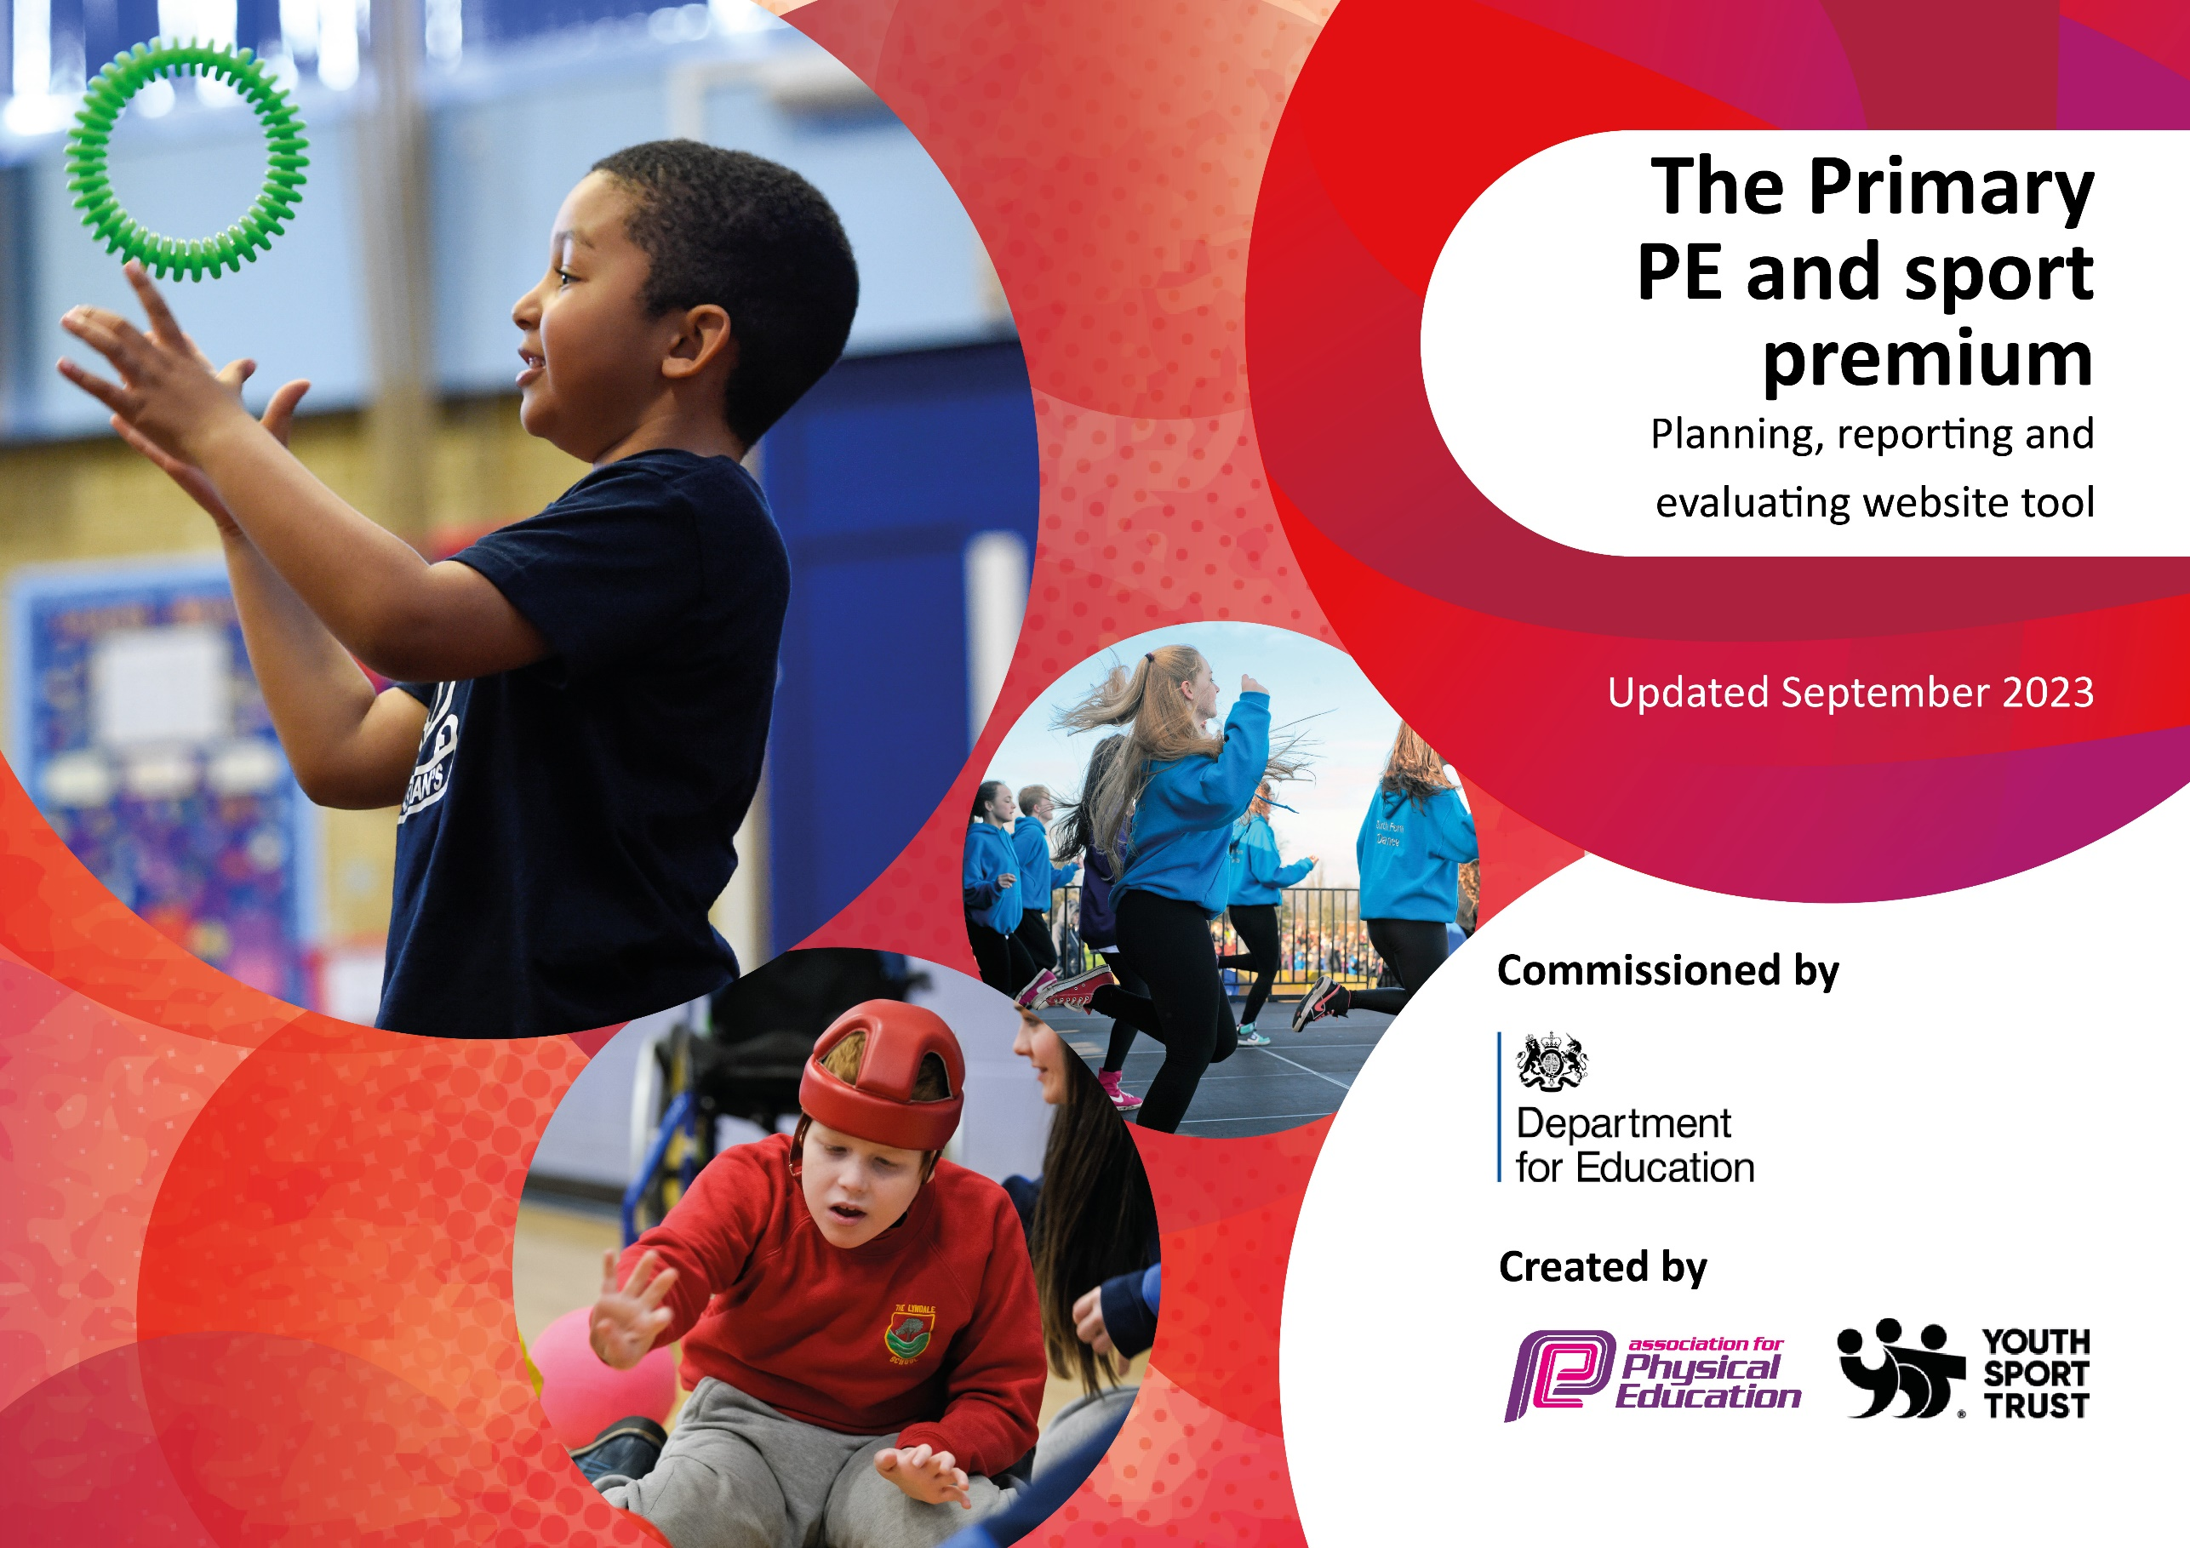

UPDATED OCTOBER 2025

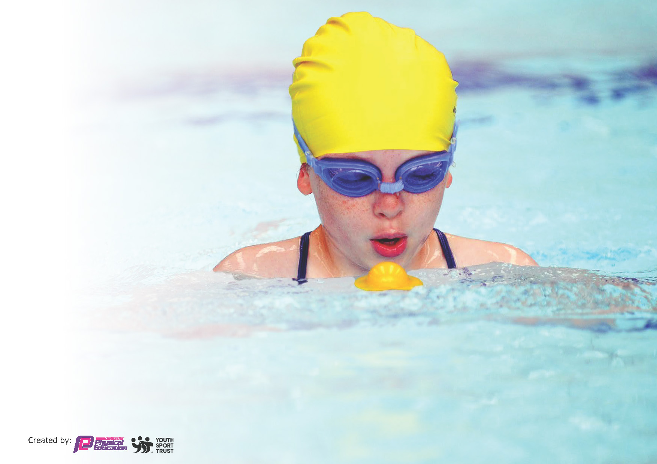
This template can be used for multiple purposes:
by:
- It enables schools to effectively plan their use of the Primary PE and sport premium
- It helps schools to meet the requirements (as set out in guidance) to publish information on their Primary PE and sport premium
- It will be an effective document to support Ofsted inspections enabling schools to evidence progress in Physical Education (PE) and evidence swimming attainment, which forms part of the PE National Curriculum. We would recommend schools consider
the Intent, Implementation and Impact of any spend, as examined within the Education Inspection Framework.

It is important that your grant is used effectively and based on school need.

Schools must use the funding to make additional and sustainable
improvements to the quality of the PE, School Sport and Physical Activity (PESSPA)
they offer. This means that you should use the Primary PE and sport premium to:

- Build capacity and capability within the school to ensure that improvements made now will benefit pupils joining the school in future years
- Develop or add to the PESSPA activities that your school already offers.

The Primary PE and sport premium should not be used to fund capital spend projects; the school’s core budget should fund these. Further detail on capital expenditure can be found in the updated Primary PE and sport premium guidance.

The Primary PE and sport premium guidance, outlines 5 key priorities that funding should be used towards. It is not

necessary that spending has to meet all the key priorities, you should select the priorities that you aim to use any funding towards.

Although completing this template is not a requirement for schools, schools are required to publish details of how they spend this funding. Schools must also outline what the impact this funding has had on pupils’ PE and sport participation and attainment and how any spending will be sustainable in the future. All funding must be spent by 31st July 2025.

The Department for Education has worked closely with the Association for Physical Education (afPE) and the Youth Sport Trust (YST) to develop this template and encourages schools to use it. This template is an effective way of meeting the reporting requirements of the Primary PE and sport premium.
Review of last year’s spend and key achievements (2024/2025)

We recommend you start by reflecting on the impact of current provision and reviewing your previous spend.

Activity/Action | Impact | Comments
School sports coach for half day’s provision across all age groups with focus on ball skills.  · Subscription to competition calendar over the course of the year, varied focuses including SEND and those with low levels of physical literacy.  · Annual subscription to ‘GETSET4PE’ scheme of work including medium term planning and resources across all age groups.  · 2 x 12-week courses in ‘Rugbytots’ for KS1 and EYFS children focusing on building motor skills, teamwork, communication and physical literacy through rugby skill games.  · 3 x weekly lunch time sports coaches (full of beans) | Impact on quality and range of PE provision, evidenced by 2024/5 School Games Mark award. · Varied competition participation including SEND and those with a low level of physical literacy, evidenced by pupil voice in monitoring cycle. · Planning and resources for all age groups, supporting all teaching staff including ECT colleagues. · Increase in the quality, breadth and range of after-school club provision. · Improved resources and pride in representing school. · Improved resources and outcomes in ball skills in addition to broadening range of opportunities for inter-school competitions. · Improved resources and provision for EYFS in building physical literacy and gross motor skills. | School sports coach half day provision to be maintained, staff are happy with this implementation. · Calendar subscription to be maintained. · ‘GETSET4PE’ subscription to be maintained. · ‘Rugbytots’ provision to continue. · LSA after-school club to be maintained but focus to be altered across sports, activities and age groupings. · Tennis provision to switch to an indoor athletics provision.

Key priorities and Planning
This planning template will allow schools to accurately plan their spending.

Action – what are you planning to do | Who does this action impact? | Key indicator to meet | Impacts and how sustainability will be achieved? | Cost linked to the action
To purchase the LSSP competition package to involve ALL students in inter school competitions. | - Teaching staff  - A range of pupils from Year 1 – Year 6  - Mr. Davies & Mr. Stephenson | - Increase pupil confidence  - Increase pupil’s skills  - Broader experiences of a range of sports and activities for pupils  - Inclusive experiences with competitions for SEND children  - Increased participation in competitive sports | More pupils experiencing positive sporting experiences, pride at representing school, greater breadth of sporting activities available for children, publication of ‘School Games Values’. | £2,100
To continue to work with and strength links with Liverpool School Sports Partnership enhanced membership and coach to team teach and upskill staff. The LSSP Specialists will provide a unit of work every six weeks, progressive lesson plans as well as supporting teachers assessing pupils in PE.  LSSP Specialist to implement lunch time and after school club for identified children. | - PE Lead  - Teaching Staff  - Year 1 – Year 6 pupils | - Enhanced confidence, knowledge, and skills among all staff for teaching PE and sports.  - Active involvement of all pupils in consistent physical activity.  - Elevating the status of PE and sport across the school to support overall school development.  - A wider array of sports and activities made available to all pupils.  - Greater engagement in competitive sports.  - Broader experiences of a range of sports and activities offered to all pupils. | Children will develop their abilities across various aspects of PE as a result of high-quality instruction. Pupils will become more physically active. Teachers will gain from professional development through observing and learning from experts, understanding the sequence and progression within PE lessons. This approach will make PE teaching sustainable for current and future students. Encouraging children who are typically less active to participate more, promoting a healthier lifestyle. This will boost confidence and wellbeing for all children involved, with the hope that it fosters ongoing and lifelong involvement in sports and physical activities. | £3,618
Subscription to annual ‘GETSET4PE’ scheme, including long-term planning and resources. | - PE LEAD  - All teaching staff  - All playground support staff | 1. Staff Support and Development: Access to structured planning resources and comprehensive guides empowers teachers to confidently deliver high-quality PE lessons, improving teaching standards across the board.  2. Quality Teaching Resources: The scheme provides well-crafted lesson plans and visual aids, ensuring consistent delivery of PE sessions that engage all pupils and support progression in skills development.  3. Active Play and Movement Breaks: The inclusion of playground games and "active blasts" encourages physical activity throughout the school day, helping pupils stay active and focused.  4. Inclusivity: The scheme features adaptable plans that cater to all abilities, ensuring every child, regardless of skill level, is included and can participate meaningfully in PE activities.  5. Long-Term Impact: Through enhanced resources and ongoing support, teachers build sustainable skills and knowledge, fostering a culture of physical activity and improving the overall quality of PE for present and future students. | The Get Set 4 Education PE scheme positively impacts the school by providing high-quality resources and structured lesson plans that enhance the delivery of PE lessons, supporting both pupil engagement and skill development. It equips staff with the tools and confidence to plan and execute effective, inclusive sessions, ensuring consistency and progression in physical education. The scheme promotes active lifestyles through features like playground games and active blasts, keeping pupils physically engaged throughout the day. Sustainability is achieved through its emphasis on teacher empowerment, enabling staff to build long-term competence and independence in delivering PE, supported by a wealth of adaptable resources that can be used year after year. | £550
To continue to work with ‘Full of Beans” to provide targeted activities to involve the least active children and increase their physical activity and to help support activity during lunch time. | - PE Lead  - Playground support staff | - Improved Behaviour: The presence of a dedicated coach provides structured, engaging activities during lunch breaks, reducing instances of poor behaviour and promoting positive interactions among pupils.  - Support for LSAs: Following feedback from staff surveys, the coach works collaboratively with Learning Support Assistants (LSAs), offering guidance, modelling strategies, and reducing the pressure on staff during busy lunchtimes.  - Targeting the Least Active Children: The coach focuses on encouraging participation from less active pupils, providing tailored activities to help them build confidence, develop new skills, and adopt healthier habits.  - Widening Opportunities: By introducing a variety of sports and games, the coach broadens pupils' exposure to physical activities, inspiring interest and fostering a love for movement among all children. | The Full of Beans lunchtime sports coach positively impacts the school by providing structured, engaging activities that improve behaviour and promote positive social interactions during break times. The coach focuses on encouraging participation from the least active children, fostering inclusivity and helping pupils build confidence, develop new skills, and adopt healthier habits. By collaborating with and supporting LSAs, the coach enhances staff capacity to manage and facilitate active lunchtimes effectively. Sustainability is achieved through the transfer of skills and strategies to LSAs, enabling them to continue delivering engaging, inclusive activities long-term, ensuring lasting benefits for pupils and staff alike. | £3000
To ensure the ongoing availability and high standard of PE equipment. | - PE Lead  - Head Teacher  - All teaching staff | - Improved Quality of PE Lessons: Providing modern, age-appropriate equipment enhances the delivery of high-quality PE sessions, allowing pupils to develop a broader range of skills effectively.  - Increased Engagement and Participation: New and engaging equipment motivates pupils to take part in PE and physical activities, catering to a variety of interests and abilities to ensure inclusivity.  - Support for Curriculum Delivery: The equipment aligns with the school's PE curriculum goals, enabling teachers to deliver a wider range of activities and sports with ease and consistency.  - Longevity and Sustainability: Investing in durable, high-quality equipment ensures resources are available for current and future pupils, supporting the school’s commitment to maintaining a strong PE program. | Maintaining the quality and availability of PE equipment has a significant impact on the school by ensuring pupils have access to safe, functional, and engaging resources that support their physical development and enjoyment of PE. Well-maintained equipment allows for the consistent delivery of high-quality lessons, helping teachers implement the curriculum effectively and encouraging greater pupil participation in physical activities. Sustainability is achieved through regular checks, repairs, and replacements, which extend the lifespan of the equipment and reduce the need for frequent large-scale purchases. This proactive approach ensures that current and future pupils benefit from well-equipped and engaging PE sessions. | £3000
- Transport to competitions  - Swimming top up |  |  |  | £1845
Summer term extra curricular activities TBD |  |  |  | £2000

Key achievements 2025-2026
This template will be completed at the end of the academic year and will showcase the key achievements schools have made with their Primary PE and sport premium spending.

Activity/Action | Impact | Comments

Swimming Data
Meeting National Curriculum requirements for swimming and water safety.
Priority should always be given to ensuring that pupils can perform safe self-rescue even if they do not fully meet the first two requirements of the National Curriculum programme of study

Question | Stats: | Further context  Relative to local challenges
What percentage of your current Year 6 cohort can swim competently, confidently and proficiently over a distance of at least 25 metres?
What percentage of your current Year 6 cohort can use a range of strokes effectively [for example, front crawl, backstroke, and breaststroke]?

What percentage of your current Year 6 cohort are able to perform safe self-rescue in different water-based situations?
If your schools swimming data is below national expectation, you can choose to use the Primary PE and sport premium to provide additional top-up sessions for those pupils that did not meet National Curriculum
requirements after the completion of core lessons. Have you done this?
Have you provided CPD to improve the knowledge and confidence of staff to be able to teach swimming and water safety?

Signed off by:

Head Teacher: | Mrs Louise Partington
Subject Leader or the individual responsible for the Primary PE and sport premium: | Miss M Davies
Governor: | Mr P Crilly – CHAIR OF GOVERNORS
Date: | Sept 2025

