11th March 2025

**To: Parents/and those with parental responsibility of Registered pupils at**

**Our Lady Immaculate Catholic Primary School.**

Dear Parent/Guardian with parental responsibility

**Parent Governor Election**

Following the extension of the nomination period for the post of Parent Governor, we have received a nomination form received on Monday 10th March 2025, which was the final day for nominations.

As we have 1 post available and only 1 nomination, there is no requirement to hold an election and Ms Beatrix Pimental kindly accepted the offer to stand as parent governor. Her term of office will run from 11th March 2025 to 10th March 2029.

We are delighted to welcome Ms Pimental to the governing body as she takes up office and attends the next round of governing body meetings.

An updated membership of the governing body will soon be uploaded to the school website.

Yours sincerely

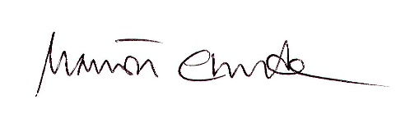

Marion Chute

School Business Manager

and Clerk to the Governors