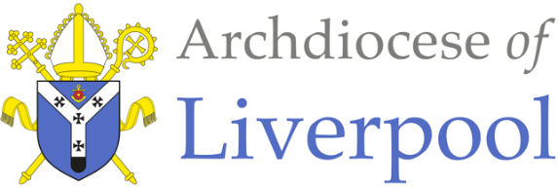
Briefing Note on the Definition of a ‘Practising Catholic’
For appointment to protected posts in Catholic Schools and Colleges.
Introduction
The Archdiocese of Liverpool requires that those appointed to protected posts within Catholic schools and as foundation directors/governors are ‘practising Catholics’. The document ‘Catholic Schools and the Definition of a ‘Practising Catholic’ - 2009 Diocesan Education Service, Archdiocese of Birmingham sets out in detail what it means to be a practising Catholic for the purpose of these appointments. This document should therefore be read in conjunction with this briefing note.
The appointment of CEO, Executive Headteacher, Headteacher, Deputy Headteacher, Head of Religious Education, Religious Education Coordinator and School Lay Chaplain
In the Archdiocese of Liverpool, it is a requirement that;
- those appointed to the roles of CEO, Executive Headteacher, Headteacher, Deputy Headteacher, Religious Education Coordinator, Head of Religious Education and School Lay Chaplain are practising Catholics at the time of application
- The Appointment of Headteachers and Deputy Headteachers in Catholic Schools – Recruitment Guidance for Governing Bodies is used by foundation directors/governors when appointing to these roles
- A representative from the Education Department must be involved in all aspects of the recruitment process, including shortlisting and interview

