Week 2 | Monday | Tuesday | Wednesday | Thursday | Friday
Main Dish  We provide a variety of seasonal hot and cold dishes, for children to freely choose from. | Beef Burger or Hot Dog served with Wedges and Beans | Sausage & Mas with Seasonal Vegetables & Gravy | Ham/ Turkey Roast Dinner served with Cauliflower Cheese, Baby Carrots, Roast Potatoes & Gravy | Homemade Spaghetti Bolognese served with Warm Ciabatta Bread | Fish Fingers served with Chips & Sweetcorn
Alternative Dish  Jacket Potatoes with tuna and other fillings available daily. | Veggie Burger | Vegetable Sausage | Cheese & Tomato Quiche | Quorn Bolognese | Meat Free Rolls
Homemade Soup
Starchy Food  Various bread choices available | Wedges | Mash | Roast Potatoes | Pasta | Chips
Vegetables  Salad bar with hummus | Beans | Seasonal Vegetables | Seasonal Vegetables | Salad | Sweetcorn
Dessert  Menu Choices may alter based upon school & pupil preference | Yoghurts, Cheese & Crackers or Fresh Fruit | Yoghurts or Fresh Fruit Salad | Choc Ice or Yoghurts | Apple Crumble or Fresh Fruit | Cheese & Crackers, Yoghurts or Fresh Fruit
All our meat is farm assured as a welfare standard. Over 50% of our food is locally sourced and 30% is organic (subject to availability) We use Organic & Fairtrade Produce. Food for Thought use only free range eggs.
FFT is a ‘not for profit’ School Company owned by its Partner Schools- Our Meals are prepared Daily
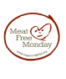
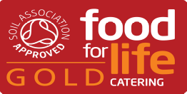
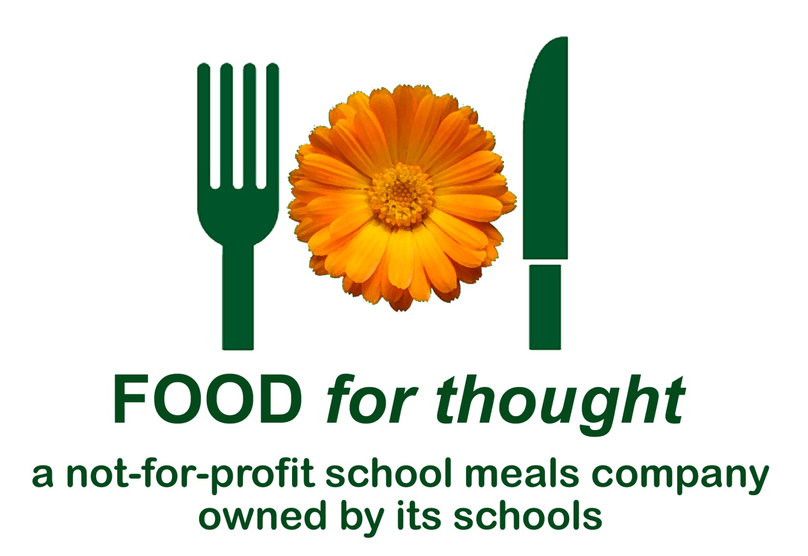
DAILY CHEF SPECIALS!
Week Commencing 19/04/2021

