Suggested reading/ writing activities for children in Y2 based on ‘Penguin Trouble’ on Rising Stars- Turquoise
When Finn, Asha, Tess and Rav are transported to the Antarctic, they meet a family of emperor penguins. The Penguins help the friends stay warm-can the friends help the penguins in return?

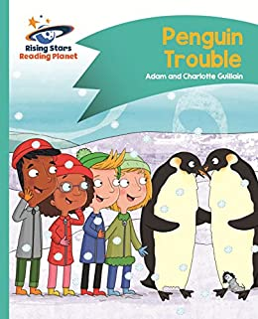
Before reading
- Have a look at the front cover and talk about: Where do you think the friends are in the story?
- Discuss what you think the trouble might be!

Activities to complete-
1.After reading the story complete the comprehension questions at the back of the book online or written in your book. As a challenge you could create a question about the book for a member of your family to answer!
2.There are a lot of unfamiliar words in this book, 10 of which are stated on the first page. Could you use a dictionary (online or a paper copy) to find the definitions of these words and create a glossary for this book?
3. The emperor penguins are such beautiful creatures and feature a lot in this book. Create your own fact file about the emperor penguin by using information and images from the book or researching using videos and bbc websites online. Your fact file can have labelled pictures, descriptive sentences and fun facts.
4. If you were to meet the characters from the story, what would you like to ask them about their visit to Antarctica? Write your questions down making sure you use capital letters and questions marks correctly.
5. The emperor penguins live in Antarctica, which is a very cold continent. Do you know anything about this continent or the countries within it? Have a go at researching soe facts and create a mind map with all your new knowledge.

.

