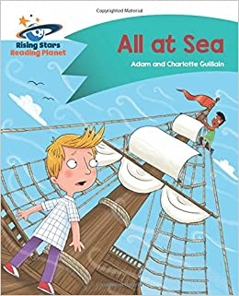
Suggested reading/ writing activities for children in Y2 based on ‘All at Sea’ on Rising Stars- Turquoise
Finn and Rav are finding out about explorers at the museum. Suddenly, they are transported back in time to some sailors who are lost! Can the boys help these explorers from the past?
Before reading
- Have a look at the front cover and talk about: Who is at sea? Why do you think they look worries?
- In the blurb it says ‘transported back in time’. How far back in time do you think they will go and why?

Activities to complete-
- After reading the book complete the comprehension questions at the back , this can be done online or you can have a go at writing down your answers in full sentences.
- Page 8- On this page the children meet the Captain. The Captain is in charge of the ship. If you could meet the Captain of this ship in the story, what would you want to ask him? Write down your questions and then you could have a go at role playing being the Captain with a family member to answer them. If you get yourself dressed up to become the character of the Captain, we would love to see photos.
- Christopher Columbus is a famous explorer. Could you research facts to create an informative poster about him? There is a ppt attached that will get you started. Remember that facts are statements that should be written in full sentences with capital letters and full stops.
- The children in the story help the Captain follow a map to find land. Could you hide 4 items around your home and create a map for a family member to follow to find them? Your map could have a list of instructions to find each clue. You could have a go at making the map look old and authentic by using wet tea bags to stain its colour.
- If you were a captain and found your own desert island, what would it look like? What creatures would you find? What noises would you hear?
Write a letter to your friends back home describing your desert island.
Remember that an object you can see, hear or touch is called a noun and remember to use adjectives to describe your nouns. For an additional challenge you could even try using some verbs to describe what things are doing. Here are some examples;
Dear Friend,
I can’t believe it! I have actually found a desert island. The sand is golden and still. The trees are tall and thin, swaying slowly in the gentle breeze. I can hear the loud squawking from the toucans playing.

Remember to email your wonderful work to year2@oliprimaryschool.co.uk

