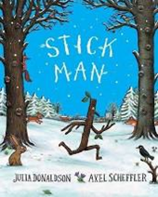
Week beginning 18.1.21
English Focus: Stick Man by Julia Donaldson
Over the next few weeks we will be focusing on the story ‘Stick Man’ written by famous author Julia Donaldson. We will be sending you your very own copy of the story soon, so this week we are going to have a look at the book cover and find out lots of information before we read the story.

Activity 1: Exploring the book cover
Look at the image of the front cover from the book together. What is the title of the story? Who wrote it? Who is the illustrator? What can you see in the picture? Can you record your findings in your red book/on paper.

Activity 2: Making predictions about the story
Look at the picture from the front cover. What do you think will happen in this story? Who is Stick Man? What will he do? Where will he go? Who will he meet? Can you record your thoughts and ideas in your red book/on paper?

Activity 3: How to make a stick man
How would you make a stick man? What equipment would you need? What would you do? Can you write some instructions to show your friends how you would make one?

Activity 4: Spelling Activity
Today can you have a go at reading/spelling the following Common Exception Words
the | do | to | today | of

Activity 5: Sentence writing
Can you use yesterday’s spelling words in a sentence? How many sentences can you write? Remember a sentence starts with a capital letter, has a space between each word and a full stop at the end.

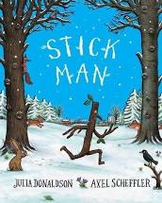
What do you think will happen in the story?
Who is the illustrator?
Who is the author?
What is the title?
Front Cover

