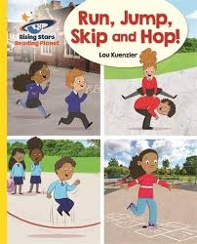

**Week beginning 25.1.21**

**English Focus: Instructions**

Over the next few weeks we will be focusing on the story ‘Stick Man’ written by famous author Julia Donaldson. We will be sending you your very own copy of the story soon, Unfortunately the order has not been delivered in time for this week so this week we are going to have a look at **instructions and reading the book Run, Jump, Skip and Hot on Rising Stars**

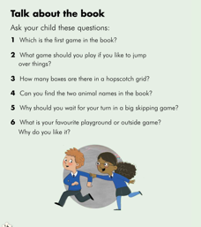

**Activity 1: Exploring the book**

Read the book online and answer the questions at the back of the book.

**Activity 2: Instructions**

Using one of the games in the book **Run, Jump, Skip and Hop** and write a set off instruction on how to play the game. Then test out the instructions yourself by following each step. You can edit them if you need to move or add additional instructions.

Remember a set of instructions needs the following:

* clear layout
* a 'You will need' list which explains what tools are required
* numbered points
* [**'bossy' verbs (imperative verbs)**](https://www.theschoolrun.com/what-are-imperative-verbs) such as 'put', 'take', 'mix', 'spread'
* Instruction texts also often use time connectives at the start of each numbered point ('First', 'Next', 'Then' and 'Lastly').

**Activity 3: Spelling Activity**

Today can you have a go at reading/spelling the following Common Exception Words

|  |  |  |  |  |
| --- | --- | --- | --- | --- |
| **some** | **I** | **my** | **me** | **you** |

**Activity 5: Instructions**

Can you practice writing a set of instructions on how to make a sandwich? How many sentences can you write? Remember a sentence starts with a capital letter, has a space between each word and a full stop at the end. (Below is a template of you would like to use it or please feel free to write your own and add your own picture)

A set of instructions on how to make a sandwich.

**You need:**

_________ MCj02904840000[1] _________ MCj02642520000[1] _________MCj02325790000[1] ________MCj02325640000[1]

_________ MCj02325820000[1] _________ MCj02507990000[1]

________MCj02328300000[1]

1. ______ pick up the ________.

2. _______ the butter across the __________.

3. _______ cut some cheese and ________ on the bread.

4. Add some leaves of _________.

5. Pour ________ some salad cream

6. Carefully _________ on some chopped __________.

7. ______ the ___________ in half with the _______.

8. Place the sandwich on a ___________.

9. Serve the sandwich.

What do you think will happen in the story?