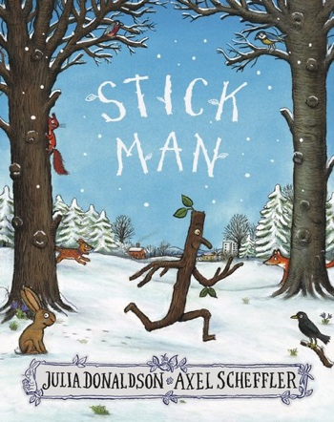
Week beginning 1.2.21
English Focus: Stickman
Over the next few weeks we will be focusing on the story ‘Stick Man’ written by famous author Julia Donaldson. We will be sending you your very own copy of the story soon, please can you come into the office to collect your own copy of the book.

Activity 1: Exploring the book: if you haven’t managed to collect your book from the school office then watch the film of the book below. Immerse yourself in the story.
https://www.bbc.co.uk/iplayer/episode/b06t09rk/stick-man
Activity 2:
Choose your favourite character from Stickman, describe them to a friend and then write some sentences about what they are like and why you like them. You can choose from Stick Man, Stick Family. Stick Family. Dog.. Swans.. Santa.

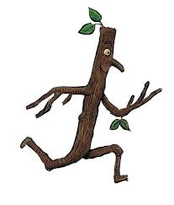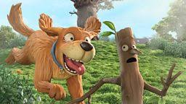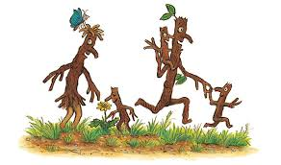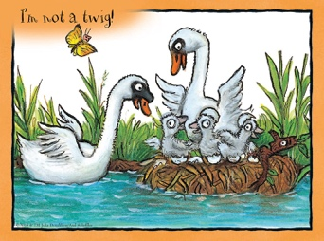
Remember a character description needs the following:
- Clear layout
- Full sentences, including capital letters, full stop and finger spaces.
- Adjectives – to describe the characters.

Activity 3: Spelling Activity
Today can you have a go at reading/spelling the following Common Exception Words
our | from | go | her | one

Activity 4: Rhyming words
- Find all the rhyming words in the book and use them to make your own rhyming dictionary.
Activity 5: Rhyming words.
- Find all the rhyming words in the book and write down a word that rhymes. Set your work out like a table:
Word from book. My rhyming word.

What do you think will happen in the story?

