Our Lady Immaculate Primary School Home Learning Overview Year 1 week beginning 18th January 2021
Mrs Bradley and Mrs Bowcock
• Resources are also linked within this document – click on ‘PDF’, ‘weblink’, ‘PowerPoint’ or ‘video’ below to link to this.
• All activities can be completed on paper or in your child’s home learning book. We would love you to send us photos of their work to our email address year1@oliprimaryschool.co.uk
• Complete the activities that you can, as best as you can, with the time and support available to you.
English: Reading and writing | 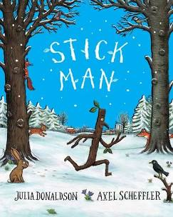  Log on to Rising Stars Rising Stars Login and access the home school reading book set by your teacher. Attached is a daily breakdown on each activity for the day. English Overview  Spelling: HFW (See attached document)  Grammar (Sentence work – see attached document)
Phonics | 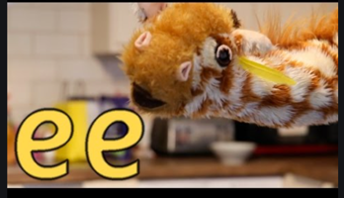  Mr Thorne does ee  Purple Mash
Maths | Length & Height: Work through the PowerPoints with activities attached. Aim for one session a day.  Length and measure  Flashback 4  Reasoning & Problem Solving.
Science | 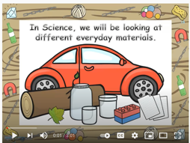  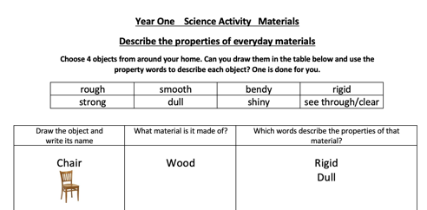  Materials: What are the properties of materials?  Materials  Complete the worksheet.
Geography | Seasons & Typical Weather: Please can you carry on completing your weather diary for each day, we will then look at the difference in weather from another part of the world.
PSHE | PSHE Lesson Plan 2  Reducing for the Planet.  Having considered the negative effects of throwing away rubbish, especially non-biodegradable items, pupils start looking at ways of counteracting this. In this lesson they explore what it means to reduce rubbish and waste and look at how some people go about this. They begin to think about ways they can reduce classroom waste and rubbish.
RE | Special Friends: Look at the PowerPoint. Can you draw and write in your book some of the different people who do special jobs in church?  Can you write about the special jobs they do?

