Suggested reading/ writing activities for children in Y2 based on the quality text ‘Fantastic Mr Fox

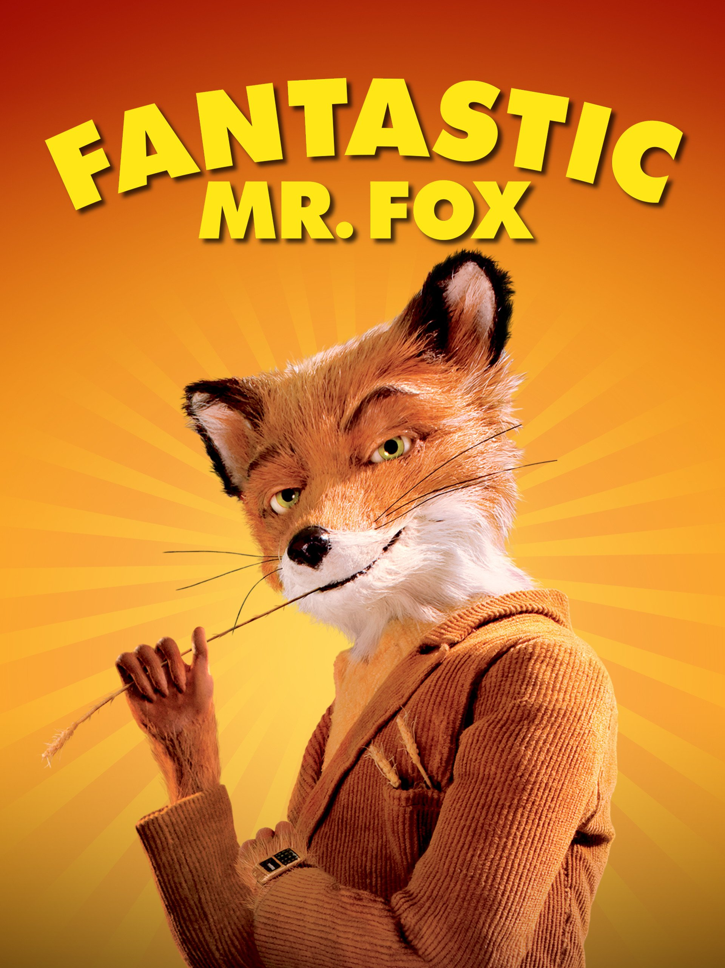

We hope you enjoy our new class text and look forward to exploring it chapter by chapter!

Activity 1-
Before even opening the book, take a look at the front cover and the blurb. What do you think the book will be about? What type if characters might it include and what settings might they explore?
Create a mind map of all your ideas and keep it safe so you can see if your predictions are right when we read the book tomorrow.

Activity 2-
Read chapter 1. This chapter introduces the 3 farmers. Can you find all of the adjectives (describing words) or noun phrases (short phrases describing things about the character) related to each farmer and complete the vocabulary grid attached to the planning timetable.

Activity 3- Choose your favourite farmer that you read about yesterday and write a character description of them. Remember you can use your vocabulary grid from yesterday to help you. You may want to draw a picture of your farmer first and then write descriptive sentences underneath.

Activity 4-
Read the first page of chapter 2. Using only what you have read can you decide whether you think the Fox is a good or bad character and explain why? This could be written or verbal and we would love to see what you think!

Activity 5-
Continue reading until the end of chapter 3. Complete the comprehension questions attached to the weekly timetable plan.

