Year 1 Home Learning Activities:

Handwriting:
Have a go at practicing our pre-cursive letters using the attached letter mat.

PSHE:
Using the person template, write and draw in the shape what makes you a good friend (eg kind, funny etc) use different colours if you like.
Draw a picture in the frame of your family and talk about/write about why they are special to you.

Handwriting – pre cursive letters: Practice
writing the letters using our pre-cursive style. Can you write any words using the letters?

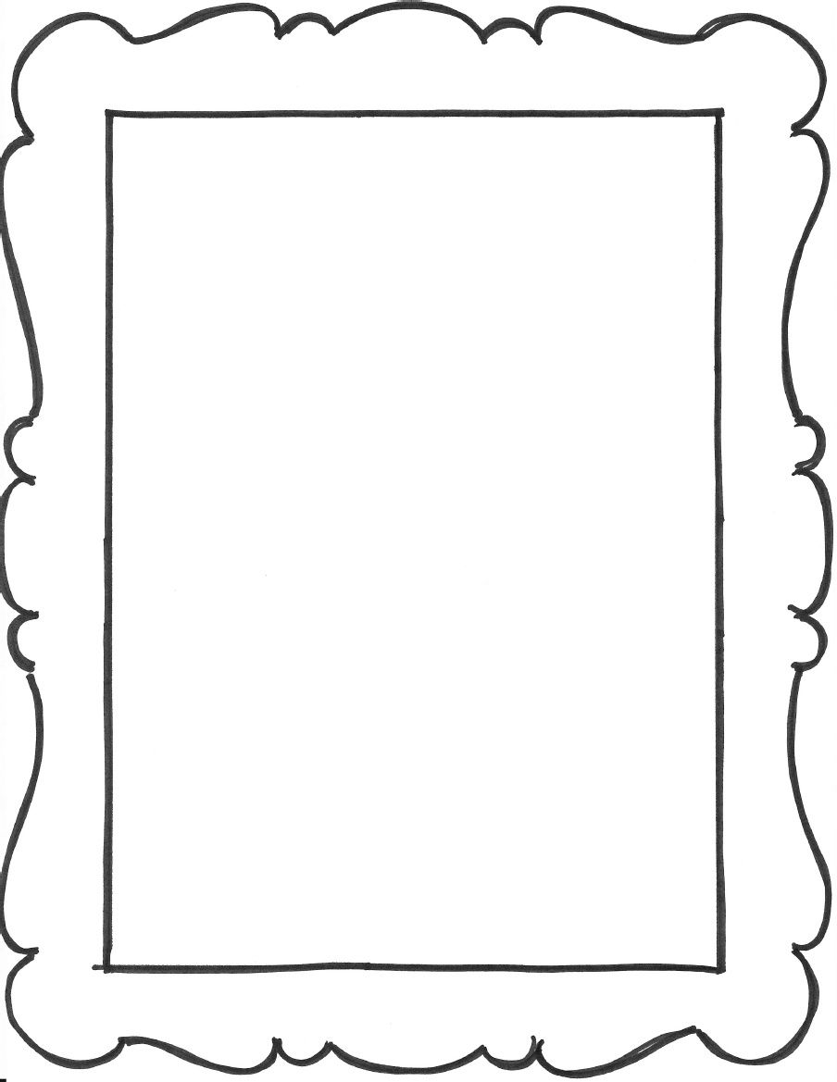

My family are special because
____________________________

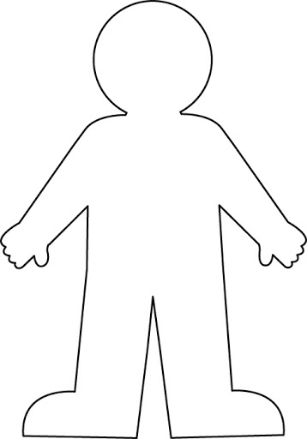
Why I am a good friend…

