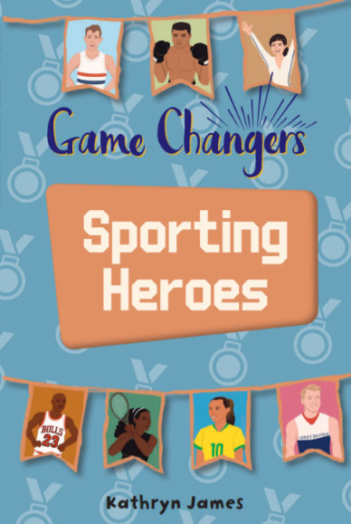
Week beginning 15th June
Suggested reading/ writing activities for children in Y6 based around the new book ‘Game Changers’ on Rising Stars Saturn: blue red
This book includes brief biographical recounts of a number of game changers from the world of sport, from the athlete Roger Bannister to football icon Marta and Paralympic star Jonnie Peacock. Each chapter follows a similar structure: defining why the subject is a game changer and then recounting their early life and achievements. Each chapter includes quotes from the subject and ‘Did you know?’ panels highlighting interesting facts about the athlete and their sport. Each chapter also includes a brief biography of another athlete, which can provide a useful comparison.
Before reading
- Ask children if they have any sporting heroes. These could include players in their favourite football team.
- You could create a list of qualities that are important for a successful athlete, such as determination, leadership and fairness (sportsmanship).
If all the class can read the part about ‘Michael Jordan’ please page 28-36 (if your child wants to read more then that’s brilliant- it’s a great book!)
Following on from the reading- The highlighted activity is the one we will share during our Zoom chat but if you want you can do all 4
- The sporting heroes in this book often make headlines in the newspapers. Write a sports report with a sensational headline for your favourite sporting hero.
- Start a sporting diary. Write down how much you practice your sport each day or week. If you don’t have a regular sport, don’t worry! Think about starting one or write a diary about another hobby that requires practice.
- Michael Jordan and Serena Williams both redesigned their own sports kit. Try drawing and designing your own sports kit for your favourite sport.
- Re-read the quotes from the sporting heroes in this book and write your own inspirational quote that will keep you practising and perfecting your sport.
Using the Glossary This book includes lots of technical vocabulary about sport. In many cases, you can turn to the glossary at the back of the book to find an explanation for words such as ‘amateur’, ‘diplomacy’ and ‘preceding’.
Suggested Follow-up activities
Organise a family debate to choose the ultimate sporting hero, either using the examples in this book or children’s own choices. Ask them to persuade their family members why their athlete is the ultimate game changer. They could talk about their hero’s sporting achievements, personality or their ability to overcome obstacles.
Thanks for all working so hard, if your parents or carers could take a photo and email it to year6@oliprimaryschool.co.uk , we would love to see it!
The year 6 team
Mr Cotton, Miss Gallagher and Mrs McNally

Additional tasks to try once you have read the book
