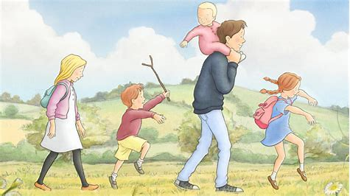

We’re Going on a Bear Hunt

5 Things to do for Literacy
Activity | Activity Ideas | Curriculum Links
1 | Encourage the children to retell the story using repeated phrases such as ‘we can’t go over it…’ and ‘we’re going on a bear hunt…’  Children could use actions, pictures or props to help them;  Pictures  You can find pictures from the story using Pinterest, Google images or on websites like this:  https://www.teacherspayteachers.com/Product/Going-on-a-Bear-Hunt-Story-Strip-2104547  Alternatively children can draw their own.  Toys and props  Small world resources can be great for retelling and changing stories.  Cuddly toys and puppets can be useful also as well as role play areas such as the home corner.  Actions  Michael Rosen demonstrates actions that can be used to help children remember and retell key parts of the story:  https://www.youtube.com/watch?v=0gyI6ykDwds | Communication and Language  Expressive Arts and Design
2 | Look at and talk about the illustrations in the book. If the book is not available look at the online video or search for images from the book. Explain to children what an illustration is and how they help to tell the story.  Children can choose their favourite part of the story to illustrate or can try to recreate one of the illustrations in the book by:  Drawing  Painting  Using chalk outside on the ground  Using sticks to mark make and draw pictures in the ground/in mud  Taking photographs of their own cuddly toy in different places around the indoor or outdoor areas.  Encourage lots of conversation as children are making their marks e.g. I can see you have drawn the long wavy grass. I like the way your mud looks so squelchy. | Physical Development  Expressive Arts and Design
3 | Go on a bear hunt!  Take a cuddly toy, preferably a bear, on a walk around the indoor and outdoor areas. Show him the sights! Model lots of language to the children as you go on your walk e.g. ‘let’s take the bear through the garden,’ let’s show the bear what is under this tree’.  Once the children have helped the bear explore the environment hide the bear and give the children clues to find him. The children could then hide the bear from each other and use the language modelled by the adult to give clues.  The children could make maps, write out clues, take photographs or use verbal instructions. | Phase 1 Phonics  Mathematics  Physical Development  Communication and Language
4 | Take a nature walk and collect things from scenes in the story-grass, mud, sticks etc. Sort the objects into tubs, bags or trays and explore them using hands. Reintroduce words and phrases from the story e.g. ‘squelchy mud’ and introduce new words e.g. fresh green grass, rough bumpy sticks.  Once they have finished exploring the children could use the objects to make a nature picture, perhaps a bear or a picture of their choosing. | Communication and Language  Expressive Arts and Design  Understanding the World
5 | Plan a teddy bear picnic.  The children can talk about what they would need for a special teddy bear picnic. They could record their ideas in various ways:  Video or voice recordings  Writing lists  Drawing pictures  Telling an adult who could model how to record into a list  Children might invite someone to their picnic. This might be someone who lives in your house or the bear itself! They could make pretend phone calls or write out their invitation, thinking about the language they would use e.g. the time and place the picnic is going to take place.  If possible, collect some of the things that the children have suggested and enjoy a picnic outside with their bear or favourite cuddly toy. | Communication and Language  Expressive Arts and Design  Physical Development

