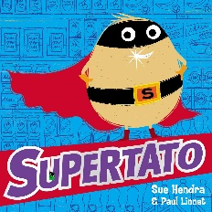
Hello everyone! Each week I will be setting some learning activities for you to do at home.
This week we will be reading the story, Supertato by Sue Hendra. Here is a link to the story on Youtube: https://www.youtube.com/watch?v=QlaMeNmTG6c.
After watching the story, talk with your adults about what happened in the story. Think about the main characters, the setting of the story, how the characters feel at different points in the story. Below are some different activities to try at home:
Super Vegetables
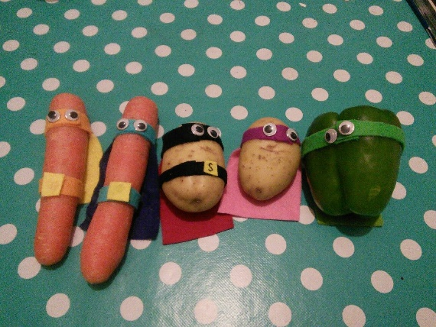
Can you make your own supertato or supercarrot? Which vegetable will you choose to transform into a superhero? What superpower will your hero have?

Dance like a superhero:
Let’s be superheroes https://www.youtube.com/watch?v=Py4fhsx3Ct4
Spidey Superpowers https://www.youtube.com/watch?v=lx08FrWBp0g

Get Creative
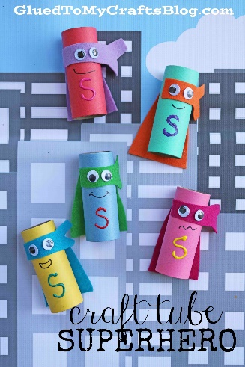
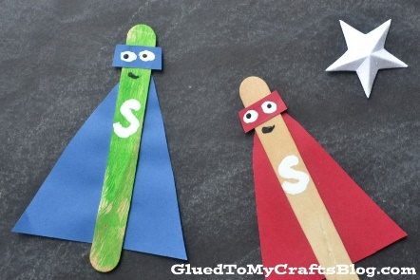
You will need:
Kitchen/toilet roll tube, paint, felt tips, googly eyes, material or coloured paper for your cape.

You will need:
Lolly ice sticks, paint or felt tips, coloured paper.

You can take a photo of your work and email it to eys-ks1@oliprimaryschool.co.uk
I can’t wait to see your superheroes!
From Miss Gibson

