Through Mission Together, children all over the world pray for each other.
The circles here represent the five continents: GREEN is for Africa, RED is for the Americas, WHITE is for Europe, BLUE is for Oceania and YELLOW is for Asia.
Mary invites you to pray for children around the world every day.
How many Hail Mary’s can you say for children around the world who are affected by Coronavirus?
As you pray a Hail Mary think about those children.
When you have finished your prayer either colour in the bead of the continent you prayed for or draw in the circle the face of a child who lives there.
How long will it take you to complete all 50 beads?

Hail Mary, full of grace,
the Lord is with thee,
Blessed art thou amongst women
and blessed is the fruit of thy womb, Jesus. Holy Mary, mother of God,
pray for us sinners now,
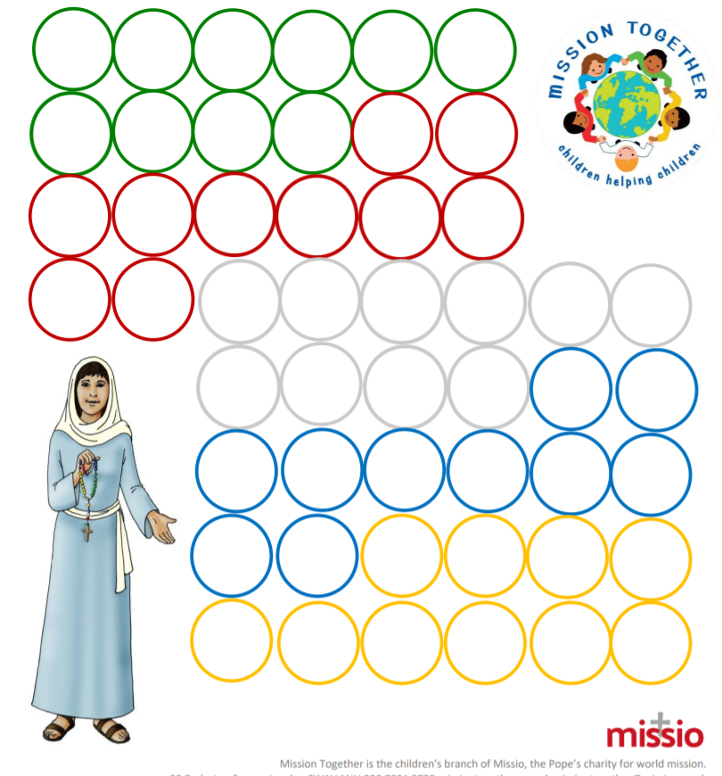
and at the hour of our death.
Amen

