Head teacher’s Desk  I would like to welcome all of our children and their families to the new school year.  We have changed the way we present out curriculum newsletter so that we can give parents information about how they can support their child’s learning at home. Any feedback on the newsletter would be appreciated.  This year we are changing the way we teach our children mathematics.  We are introducing Mathematic Mastery teaching from year 1 to year 6 and all staff attended two training days in September. The feedback so far from the children and staff from the new style math’s lessons is very positive. We will keep parents informed on how this new approach is developing and we will invite parents into school to take part in a math’s lesson later in the Spring term.  The website is a valuable resource for parents with lots of information about the work that the children are doing in school. The link below will take you straight to the curriculum pages on the website.www.oliprimary.co.uk/curriculum  HAVE YOU DOWNLOADED OUR SCHOOL APP? This is a quick and easy way to keep in touch with what is going on in school. You will receive messages and reminders to your phone and you can link easily to our website.  Go to the APP store and search “Our Lady Immaculate” and download the free app to your phone. |  | Northumberland Terrace  Everton, Liverpool. L5 3QF  T: 0151 260 8957  W: www.oliprimary.co.uk  E:admin@oliprimaryschool.co.uk | Time for tea  Term Dates for this year are available on the School Website  OCTOBER HALF TERM  Monday 22nd October to Friday 26th October  Everton Kids Holiday Club will be available throughout the October half term.  Please contact Laura on 07799 062730 for more details and for advance booking.  INSET DAY  Monday 29th October 2018  The school will be closed to children as staff will be taking part in training. |  |  | Our Lady Immaculate  Catholic Primary School  CURRICULUM NEWSLETTER  AUTUMN 2018  If you have any questions about your child’s curriculum this term, please make an appointment with their class teacher.  Class teachers are available at the end of each day by prior arrangements
How can I help my child this term?  Here are a couple of ideas…  - Practice counting 1 – 10 in lots of different ways e.g. When walking up the stairs or when playing.  - Encourage your child to be independent when dressing, put on their own shoes or wellingtons and even their own coat if they are ready too try.  - Can you read a short story with your child each night?  - Encourage your child to find you one object e.g. one spoon or one teddy. If they can do this then ask them to find two spoons or teddies.  - We kindly ask that children do not bring toys from home to school. As this can cause upset if they are damaged or lost. Thank you. .  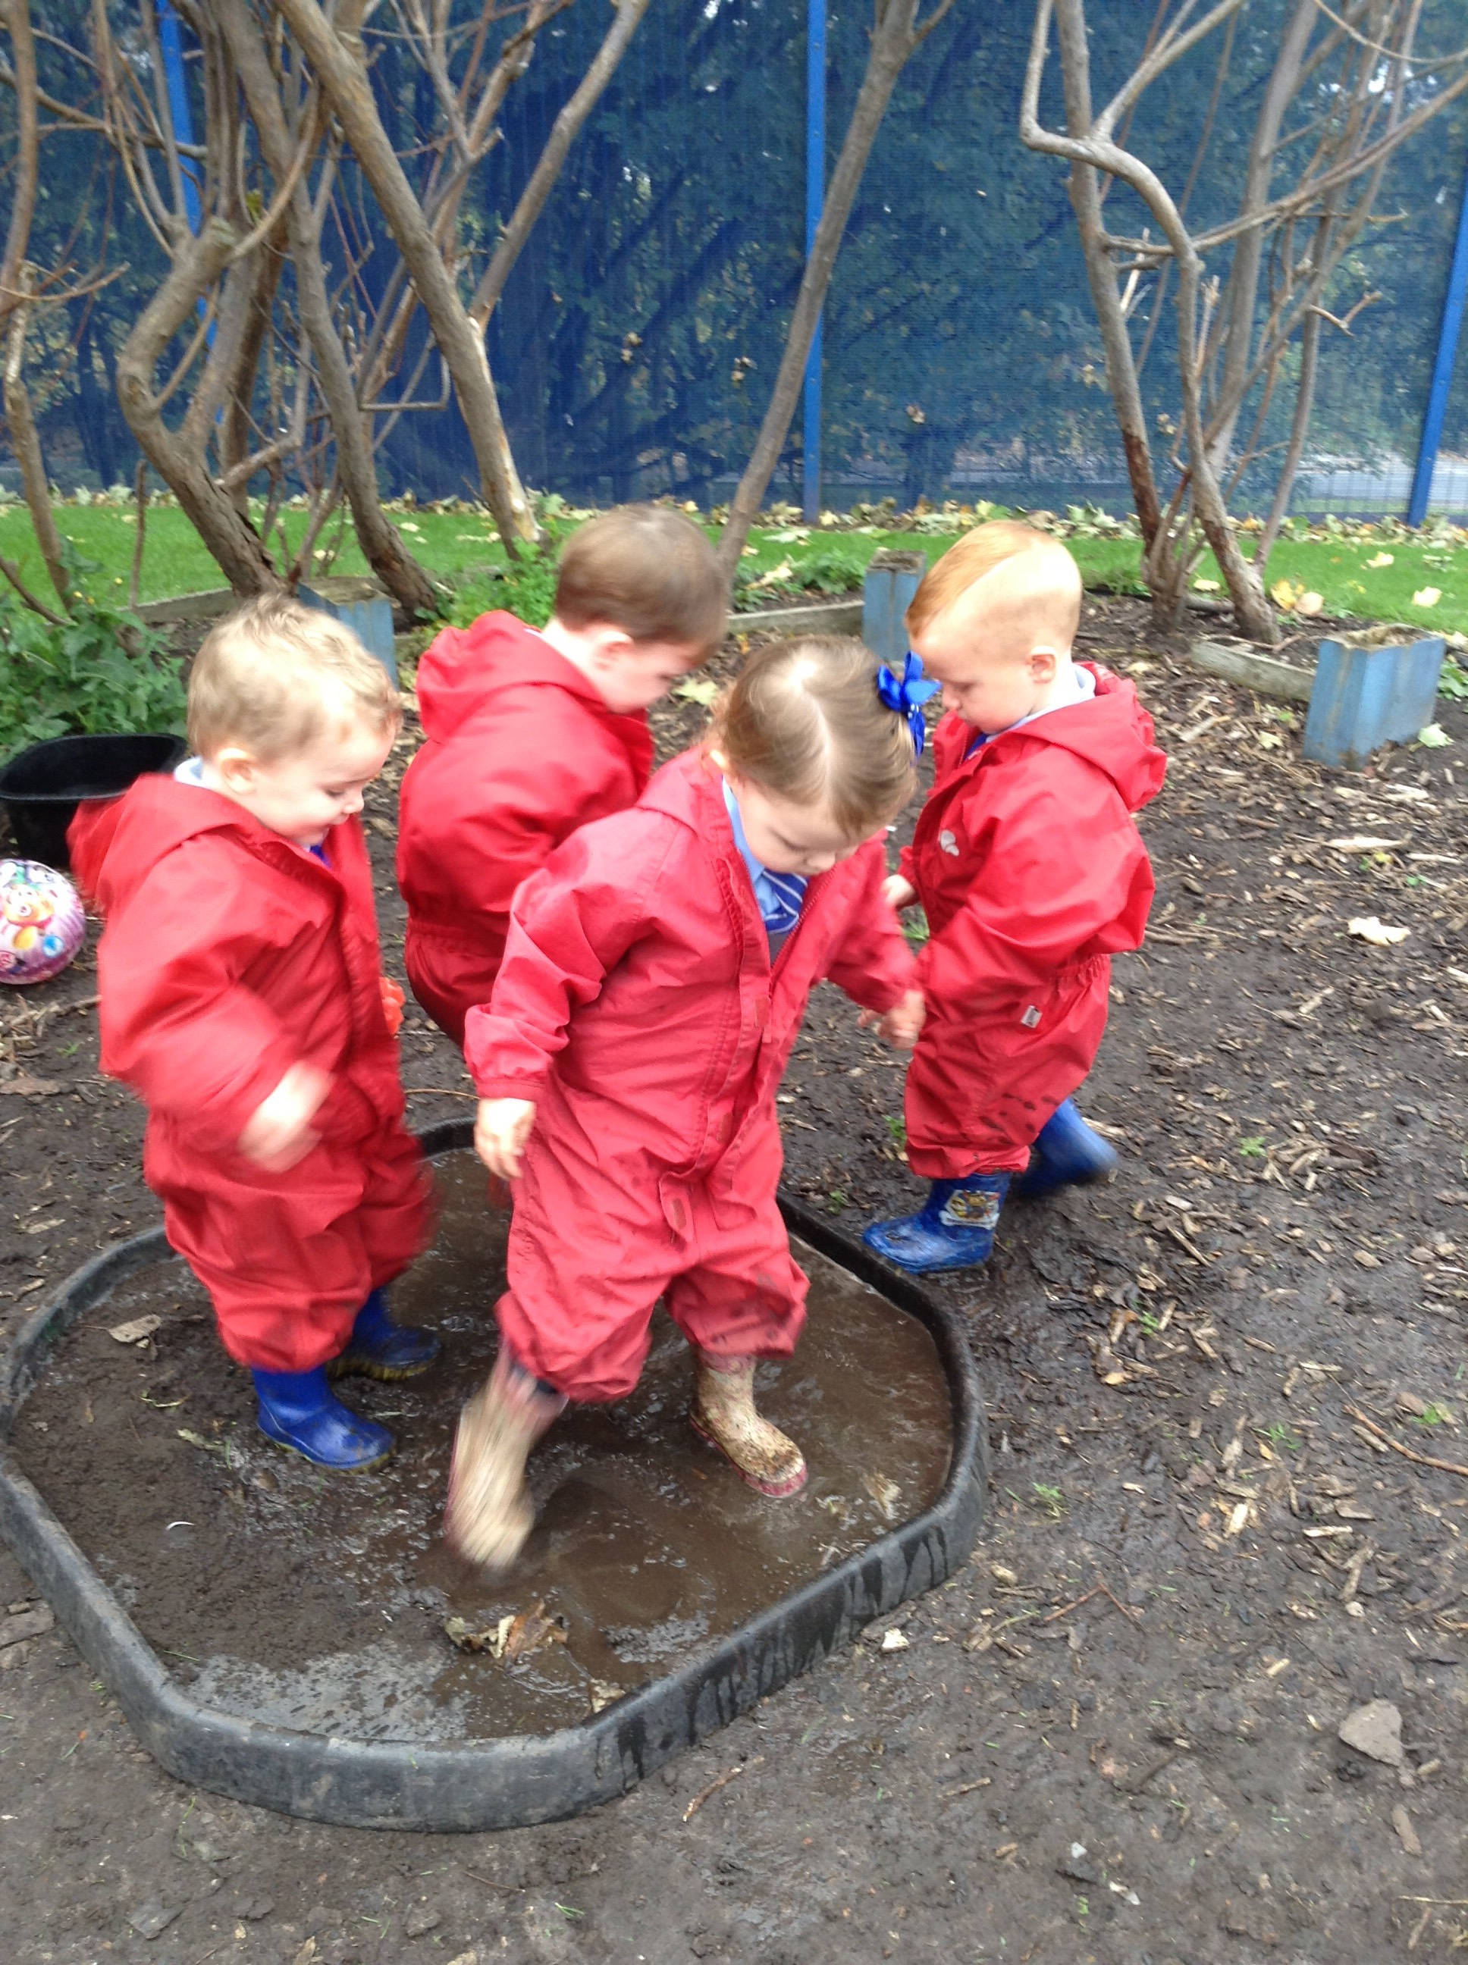 |  |  | Our book focus next term is “Elmer”  By David McKee  We will begin our learning based on the book ' Elmer’s Colours’ after half term. We are going to focus on learning our colours and mixing colours to create new shades and tones. We will then use these ideas in our planning. You can listen to the story of ‘Elmer Colour’s on you tube.  “Did you know that we do Dough Gym every day.”  Outdoor Learning  A big focus for this term is developing our New Outdoor garden area to support your children’s physical and imaginative development as well as their understanding of the world through play based activities in our outdoor learning environment. They will take part in a variety of activities including maths, literacy, communication and language, creative and exploring the world around them. The children will be playing in the outdoor environment in all weathers, wearing their waterproofs and their wellies.  We ask for your support in encouraging your child to dress and undress themselves at home. If your child doesn't already have a pair of wellies in school can you please ensure they are brought into school with their name in each boot. Thank you. |  |  |  | 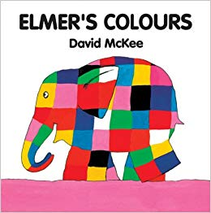  Phonics  We have started singing traditional nursery rhymes and we will be singing lots more next term. Practice singing some traditional nursery rhymes at home with your child, you can listen to the rhymes on You tube by searching 'traditional nursery rhymes.’  We have also been encouraging the children to listen to lots of different sounds and encouraging them to tell us what they have heard. This listening and attention focus is the first stage of Phonics. At home you could play a game with your child where they could tell what they have heard inside your house or perhaps when going outside for a walk.  Home School Communication Books  We give out our Home links books every Friday with a story book for you to read with your child.  Please write a comment in your child's Home links book as we enjoy reading them with your child about what you have been doing at home.

