Head teacher’s Desk  I would like to welcome all of our children and their families to the new school year.  We have changed the way we present out curriculum newsletter so that we can give parents information about how they can support their child’s learning at home. Any feedback on the newsletter would be appreciated.  This year we are changing the way we teach our children mathematics.  We are introducing Mathematic Mastery teaching from year 1 to year 6 and all staff attended two training days in September. The feedback so far from the children and staff from the new style math’s lessons is very positive. We will keep parents informed on how this new approach is developing and we will invite parents into school to take part in a math’s lesson later in the Spring term.  The website is a valuable resource for parents with lots of information about the work that the children are doing in school. The link below will take you straight to the curriculum pages on the website.www.oliprimary.co.uk/curriculum  HAVE YOU DOWNLOADED OUR SCHOOL APP?  This is a quick and easy way to keep in touch with what is going on in school. You will receive messages and reminders to your phone and you can link easily to our website.  Go to the APP store and search “Our Lady Immaculate” and download the free app to your phone. |  | Northumberland Terrace  Everton, Liverpool. L5 3QF  T: 0151 260 8957  W: www.oliprimary.co.uk  E:admin@oliprimaryschool.co.uk | Time for tea  Term Dates for this year are available on the School Website  OCTOBER HALF TERM  Monday 22nd October to Friday 26th October  Everton Kids Holiday Club will be available throughout the October half term.  Please contact Laura on 07799 062730 for more details and for advance booking.  INSET DAY  Monday 29th October 2018  The school will be closed to children as staff will be taking part in training. |  |  | Our Lady Immaculate  Catholic Primary School  CURRICULUM NEWSLETTER  AUTUMN 2018  If you have any questions about your child’s curriculum this term, please make an appointment with their class teacher.  Class teachers are available at the end of each day by prior arrangement.
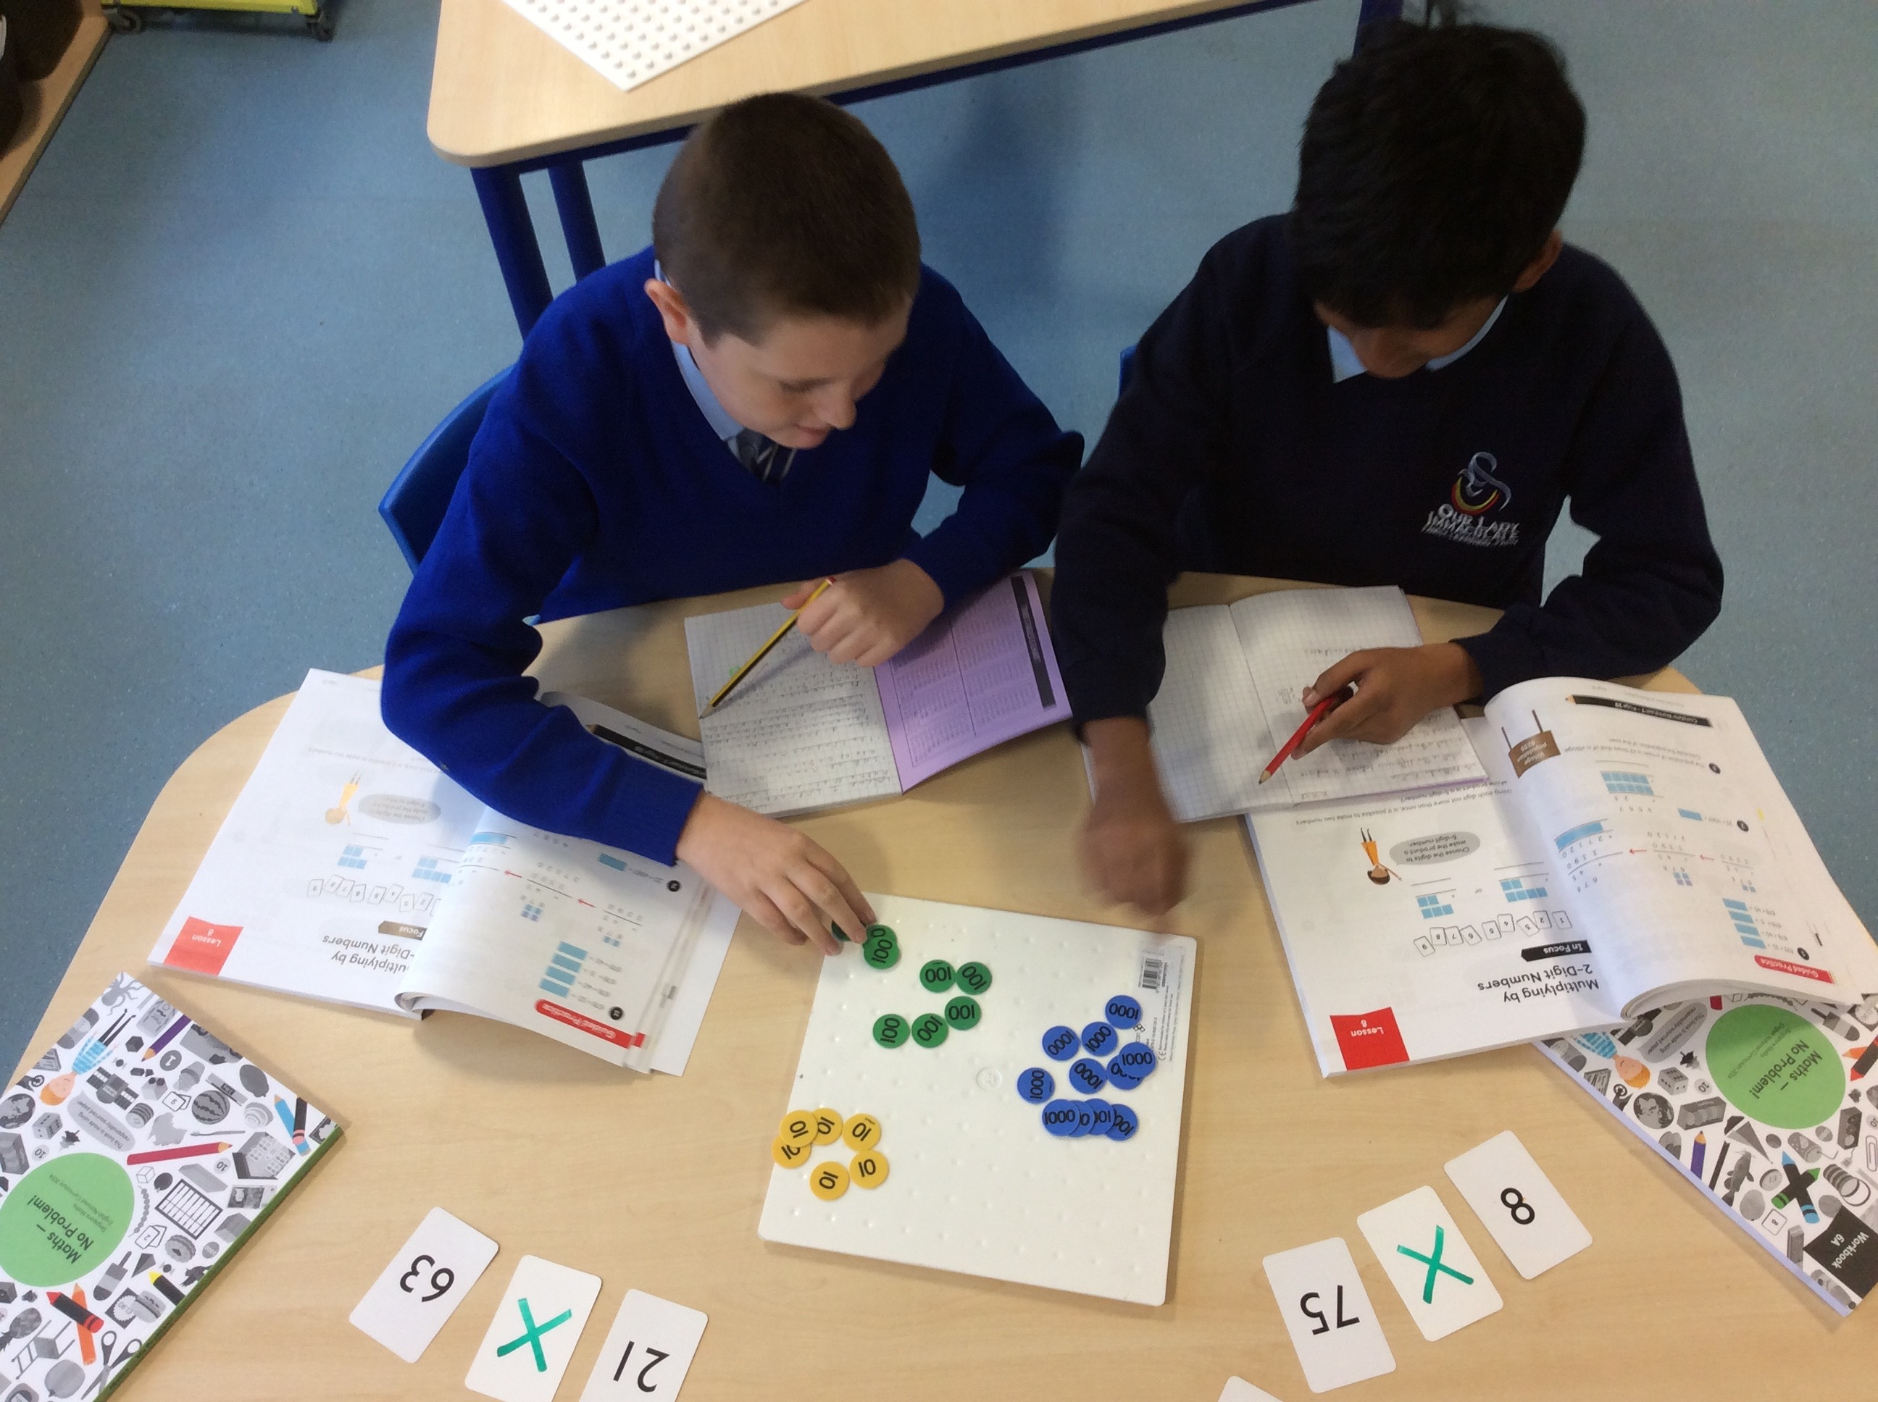  Maths Mastery in Year 6  How can I help my child this term?  Here are a couple of ideas…  - Help your child to learn their times tables, children in Year 6 should know their times tables up to 12 x 12 confidently. You can help them by practicing Maths basic skills using an iPad App – Hit the Button.  - Access PurpleMash to play spelling games along with many other educational activities. Log in information will be provided this week.  - Play World Geography games improve local and worldwide geography knowledge. United Kingdom knowledge should be a focus.  - Can you read with your child for 5 minutes each night?  - Practice their weekly spellings. Children receive their spellings every Monday from their class teacher.  - Please make sure they have their PE kit in school every week - we do Dance on a Friday and Swimming on a Thursday.  - Practice cursive handwriting. |  |  | Homework  Homework is an important task that links to the learning your child has been exposed to that week. All Year 6 pupils receive one piece on a Monday, which we ask to be in the following day to review in class and the same on a Tuesday for Wednesday.  Anti-Bullying Week commences 12th November and Year 6 have a workshop on gangs – Get Away and Get Safe.  In History we are celebrating Black History Month  As our whole school focus is dreams, you can help your child by researching the significant individual we’ll be studying – Martin Luther King. If your child produces a piece of work at home (fact file/drawing etc), please show the class teacher so it can be celebrated and displayed in class.  Our geography topic this term is, ‘I’m a year 6 pupil, can you get me out of here?’  You can help your child by looking at Google Maps together and discussing directions and how to navigate maps. You could explore how to use compasses and how they can help direct us.  Our school is working towards the History Quality Mark this year and we have our assessment next half term. |  |  |  | 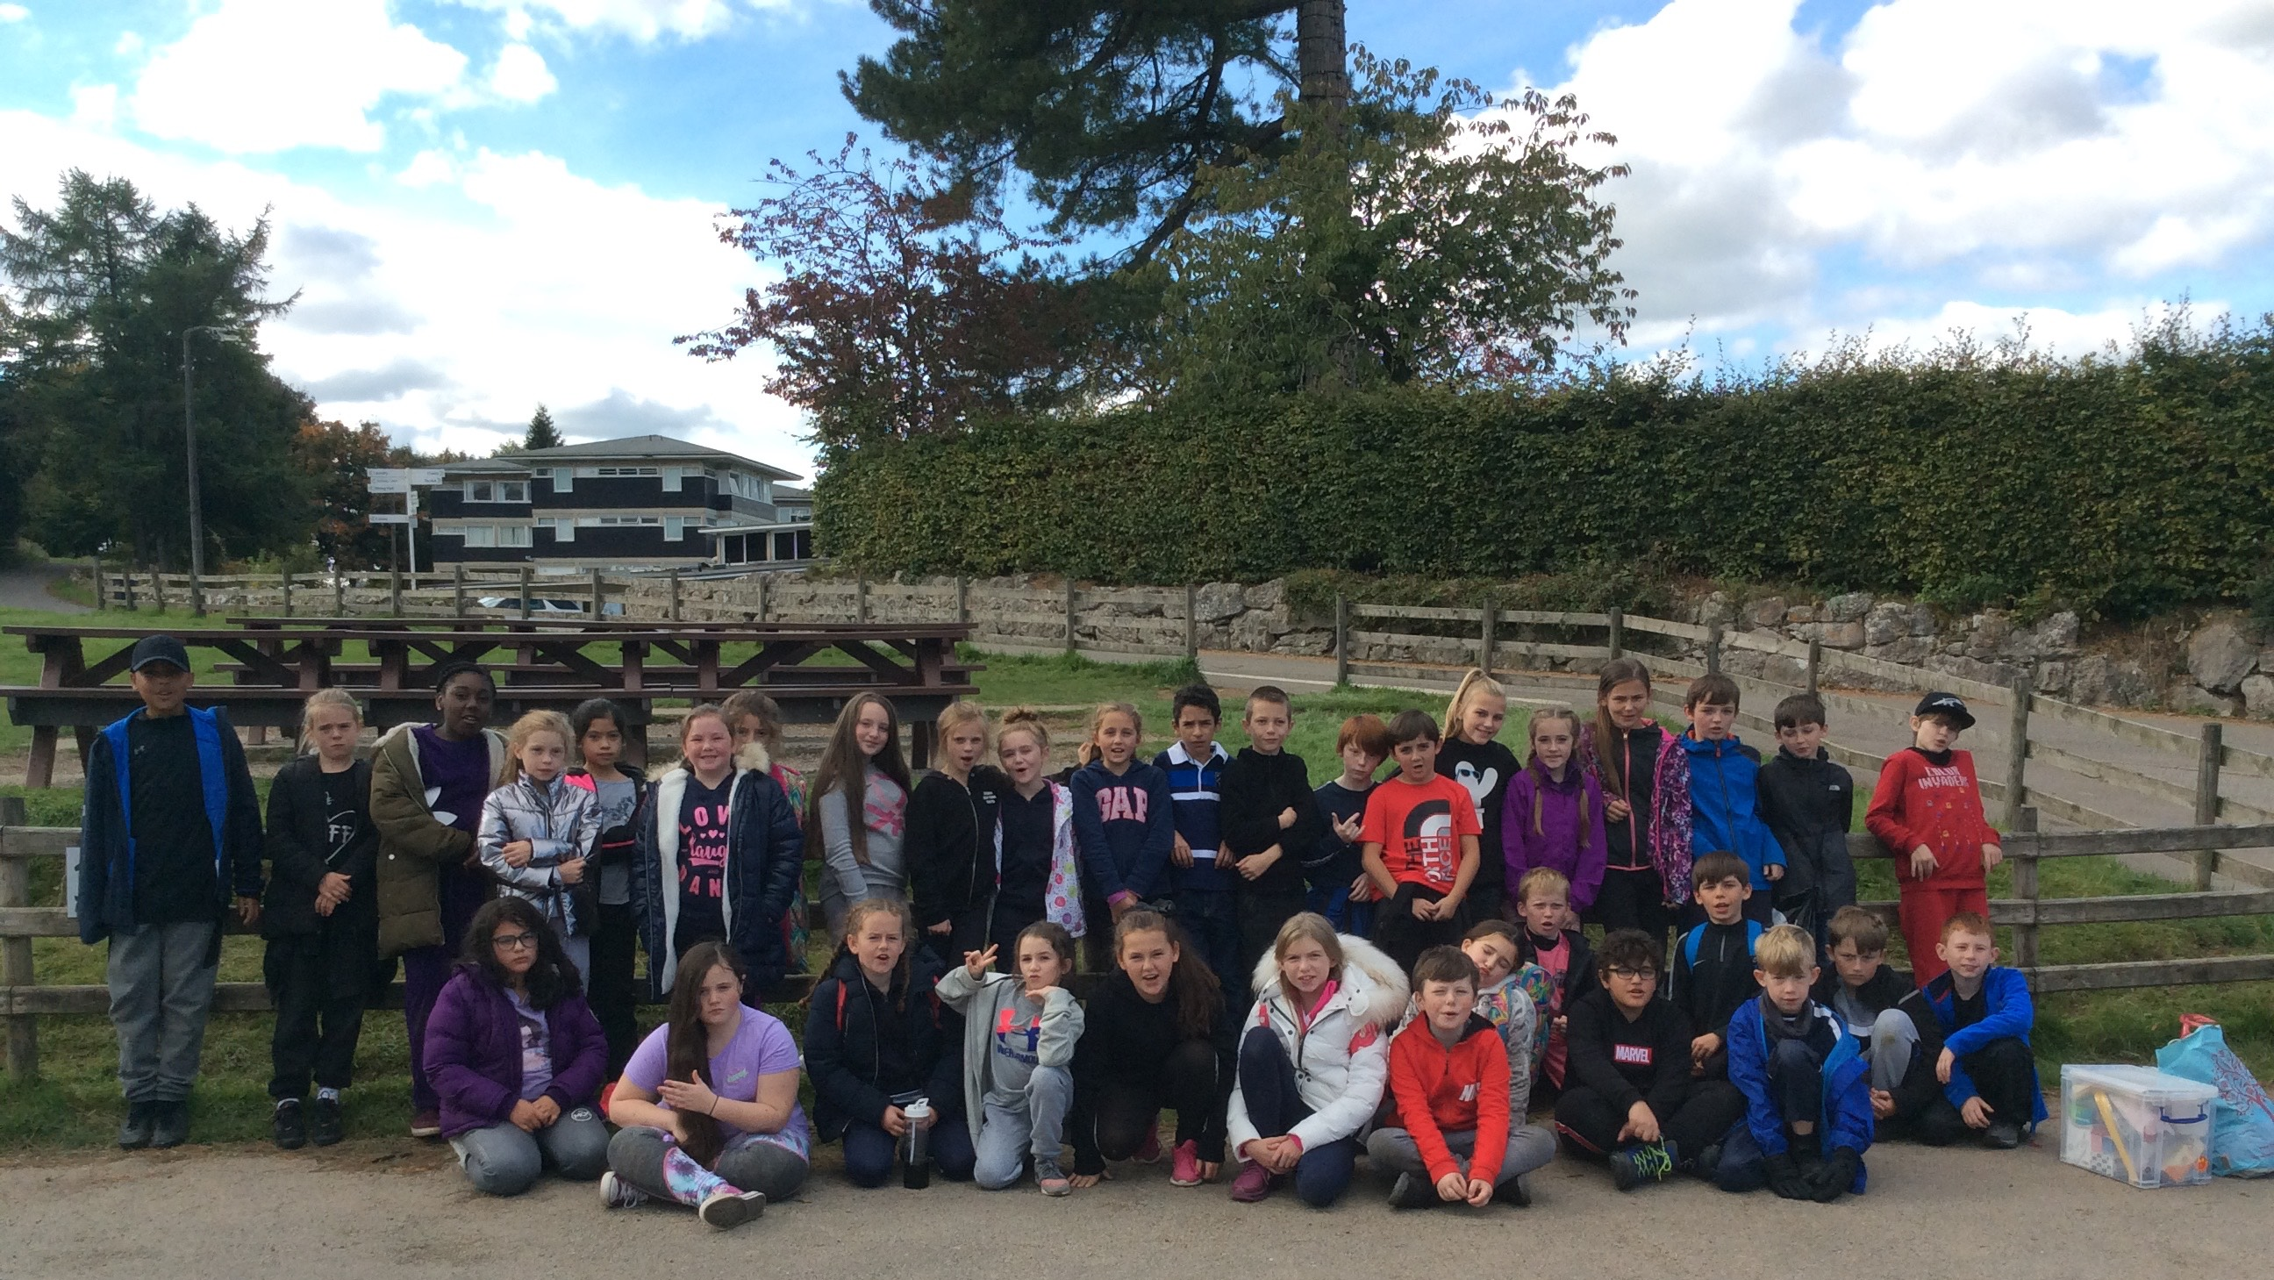  Colomendy 2018  In English we are looking at Recounts  You can help your child by discussing what recounts are where we see them. You could read some recounts with your child online such as newspaper articles and football match reports. They could practice verbal recounts with you be retelling recent events in chronological order.  In Science we are looking at Evolution  A large part of our evolution study is around inheritance. You could help secure your child’s understanding of inheritance by exposing them to family images and identifying features they’ve inherited. A scientist we’ll be studying is Charles Darwin so they could research why he is so influential in the theory of evolution. Any research completed will be celebrated in class so please show their class teacher.  Maths Mastery  We have started following math’s mastery teaching this year and you can support your child’s mathematical journey by practicing basic Maths skills at home (mental addition/subtraction and times tables) particularly for speed and accuracy.

