Head teacher’s Desk  I would like to welcome all of our children and their families to the new school year.  We have changed the way we present out curriculum newsletter so that we can give parents information about how they can support their child’s learning at home. Any feedback on the newsletter would be appreciated.  This year we are changing the way we teach our children mathematics.  We are introducing Mathematic Mastery teaching from year 1 to year 6 and all staff attended two training days in September. The feedback so far from the children and staff from the new style math’s lessons is very positive. We will keep parents informed on how this new approach is developing and we will invite parents into school to take part in a math’s lesson later in the Spring term.  The website is a valuable resource for parents with lots of information about the work that the children are doing in school. The link below will take you straight to the curriculum pages on the website.www.oliprimary.co.uk/curriculum  HAVE YOU DOWNLOADED OUR SCHOOL APP? This is a quick and easy way to keep in touch with what is going on in school. You will receive messages and reminders to your phone and you can link easily to our website.  Go to the APP store and search “Our Lady Immaculate” and download the free app to your phone. |  | Northumberland Terrace  Everton, Liverpool. L5 3QF  T: 0151 260 8957  W: www.oliprimary.co.uk  E:admin@oliprimaryschool.co.uk | Time for tea  Term Dates for this year are available on the School Website  OCTOBER HALF TERM  Monday 22nd October to Friday 26th October  Everton Kids Holiday Club will be available throughout the October half term.  Please contact Laura on 07799 062730 for more details and for advance booking.  INSET DAY  Monday 29th October 2018  The school will be closed to children as staff will be taking part in training. |  |  | Our Lady Immaculate  Catholic Primary School  CURRICULUM NEWSLETTER  AUTUMN 2018  If you have any questions about your child’s curriculum this term, please make an appointment with their class teacher.  Class teachers are available at the end of each day by prior arrangements
How can I help my child this term in year 3?  Here are a couple of ideas…  - Help your child to learn the 3,4 and 8 times tables. You can download the app ‘my times tables’ to help.  - Can you read with your child for 5 minutes each night?  - Did you go to see the giants? Have you got a map of their route for our geography topic on map skills?  - Please make sure they have their PE kit in school every week. We do PE on a Monday and Dance on a Wednesday  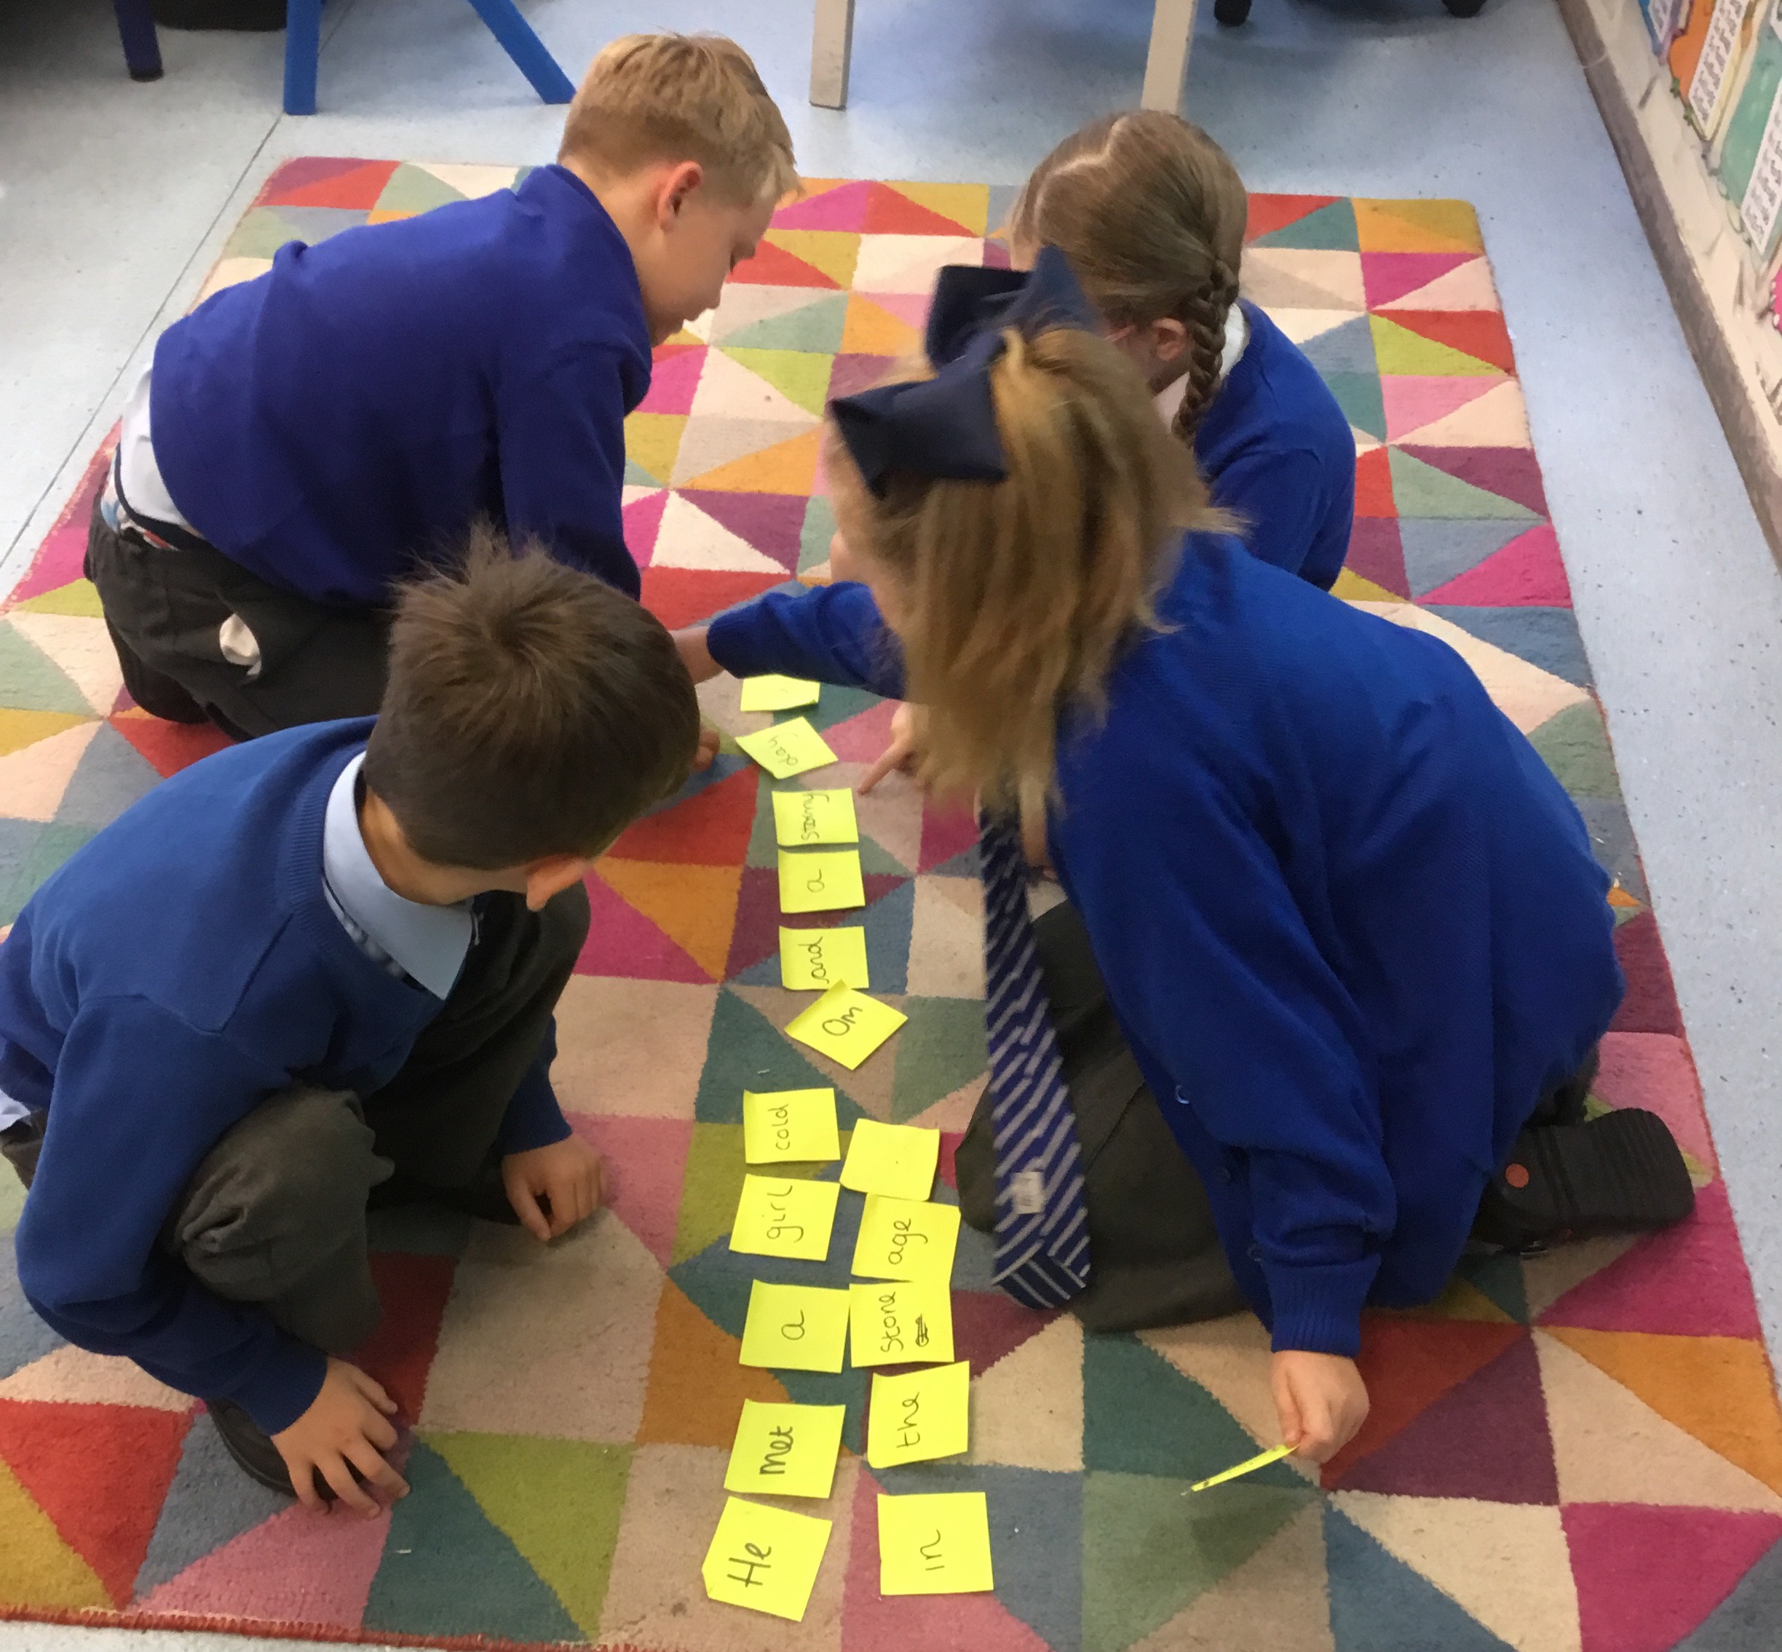 |  |  | Our topic this term is the Stone Age to the Iron Age era.  So far we have researched all about what life was like and compared with our lives today. We have written a story set in the stone age too!  We will also look at the Bronze age and Iron age era, can you do some research at home? Can you find stories, horrible histories or films to show this era?  We have our anti bullying week on the 12-16th November, this year our focus is ‘This is me!  How to get a pen license in Year 3:  This year the children will receive a pen license when they can:  - Sit their writing on a line  - Make sure their tall letters are taller than others  - Capital letters are only used for names and at the beginning of sentences  - Consistent joined cursive writing |  |  |  | In English:  We are looking at newspaper articles.  We will be looking at features of a newspaper and writing our own recounts of the giants visiting Liverpool.  We will then be moving on to Play Scripts which links to our visit to the Empire to see a Christmas pantomime.  In Maths  Our main focusses are place value and addition &subtraction. You can help your children by asking if they remember their methods on answering one question in a variety of ways.  Homework in year 3  Children have been given their spellings for the term along with times tables to learn. They will be assessed on a Friday to secure the basic skills. We will be also be giving homework as and when required to link to our topics  Phonics  We have started singing traditional nursery rhymes and we will be singing lots more next term. Practice singing some traditional nursery rhymes at home with your child, you can listen to the rhymes on You tube by searching 'traditional nursery rhymes.’  We have also been encouraging the children to listen to lots of different sounds and encouraging them to tell us what they have heard. This listening and attention focus is the first stage of Phonics. At home you could play a game with your child where they could tell what they have heard inside your house or perhaps when going outside for a walk.  Home School Communication Books  We give out our Home links books every Friday with a story book for you to read with your child.  Please write a comment in your child's Home links book as we enjoy reading them with your child about what you have been doing at home.

