Head teacher’s Desk  I would like to welcome all of our children and their families to the new school year.  We have changed the way we present out curriculum newsletter so that we can give parents information about how they can support their child’s learning at home. Any feedback on the newsletter would be appreciated.  This year we are changing the way we teach our children mathematics.  We are introducing Mathematic Mastery teaching from year 1 to year 6 and all staff attended two training days in September. The feedback so far from the children and staff from the new style math’s lessons is very positive. We will keep parents informed on how this new approach is developing and we will invite parents into school to take part in a math’s lesson later in the Spring term.  The website is a valuable resource for parents with lots of information about the work that the children are doing in school. The link below will take you straight to the curriculum pages on the website.www.oliprimary.co.uk/curriculum  HAVE YOU DOWNLOADED OUR SCHOOL APP? This is a quick and easy way to keep in touch with what is going on in school. You will receive messages and reminders to your phone and you can link easily to our website.  Go to the APP store and search “Our Lady Immaculate” and download the free app to your phone. |  | Northumberland Terrace  Everton, Liverpool. L5 3QF  T: 0151 260 8957  W: www.oliprimary.co.uk  E:admin@oliprimaryschool.co.uk | Time for tea  Term Dates for this year are available on the School Website  OCTOBER HALF TERM  Monday 22nd October to Friday 26th October  Everton Kids Holiday Club will be available throughout the October half term.  Please contact Laura on 07799 062730 for more details and for advance booking.  INSET DAY  Monday 29th October 2018  The school will be closed to children as staff will be taking part in training. |  |  | Our Lady Immaculate  Catholic Primary School  CURRICULUM NEWSLETTER  AUTUMN 2018  If you have any questions about your child’s curriculum this term, please make an appointment with their class teacher.  Class teachers are available at the end of each day by prior arrangements
How can I help my child this term?  Here are a couple of ideas…  - Practice hearing the initial sound in words by playing a game of 'Ispy'  - Practice writing your name, please speak to your child's class teacher if you would like a copy of your child's name card.  - Can you read with your child for 5 minutes each night?  - Encourage your child to look for and identify numerals in the environment e.g. on doors, price tags in the shops and on buses.  - Begin to find one more and one less of a given number  - Did you go to see the giants? Can your child bring a photo in to school?  - Please make sure they have their PE kit in school every week. We do PE on a Tuesday and Dance on a Thursday.  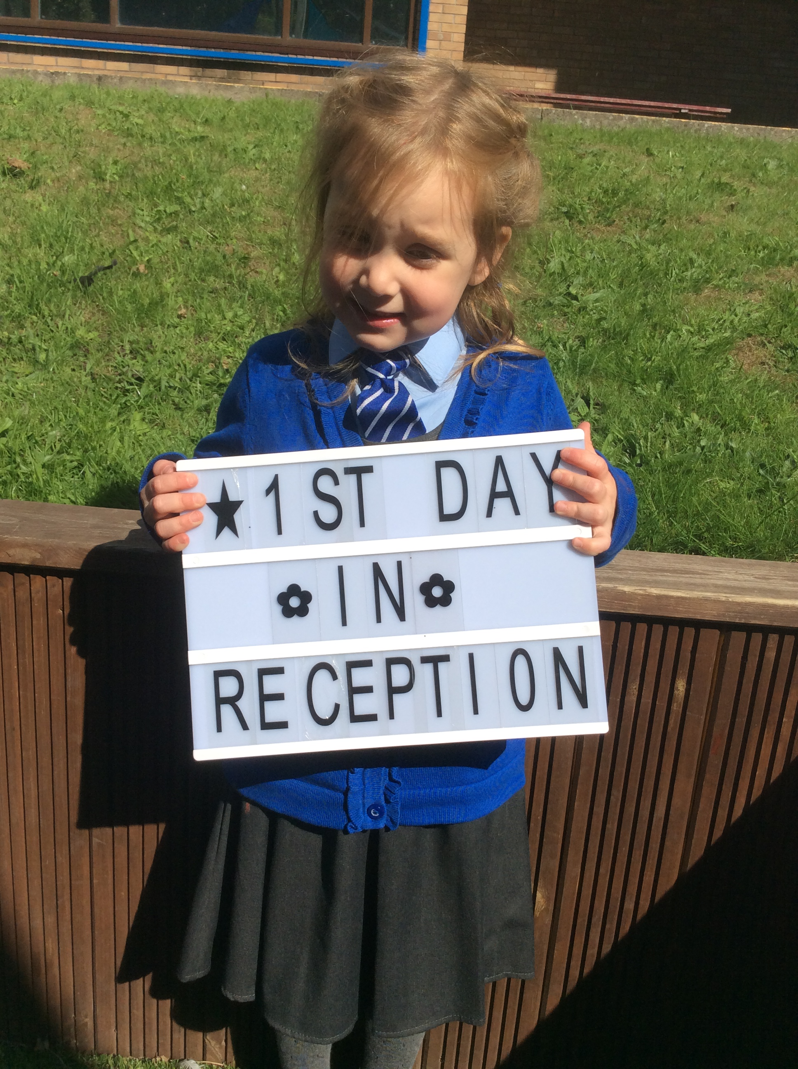  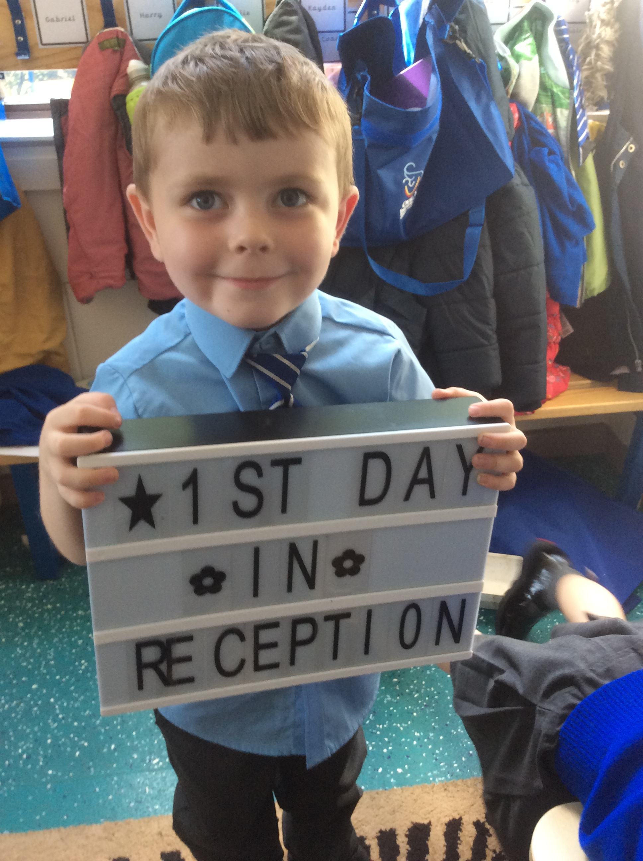  - We kindly ask that children do not bring to school toys from home. This can cause upset if toys are damaged or lost. |  |  | Our book focus next term is 'How to Catch a Star' by Oliver Jeffers.  We will begin our learning based on the book 'How to Catch a Star' after half term. We would love to hear what activities your child would like to complete linking to the story and space. Please ask your child's class teacher for a star template to write your child's ideas on. We will then use these ideas in our planning. You can listen to the story on Youtube.  “Did you know that we now have music lessons on Wednesday ’.”  Outdoor Learning  A big focus for this term is supporting children’s physical and imaginative development as well as their understanding of the world through play-based activities in our outdoor learning environment. They will take part in a variety of activities including maths, literacy, communication and language, creative and exploring the world around them. The children will be playing in the outdoor environment in all weathers, wearing their waterproofs and their wellies.  We ask for your support in encouraging your child to dress and undress themselves at home. If your child doesn't already have a pair of wellies in school can you please ensure that they are brought into school with their name in each boot. |  |  |  | 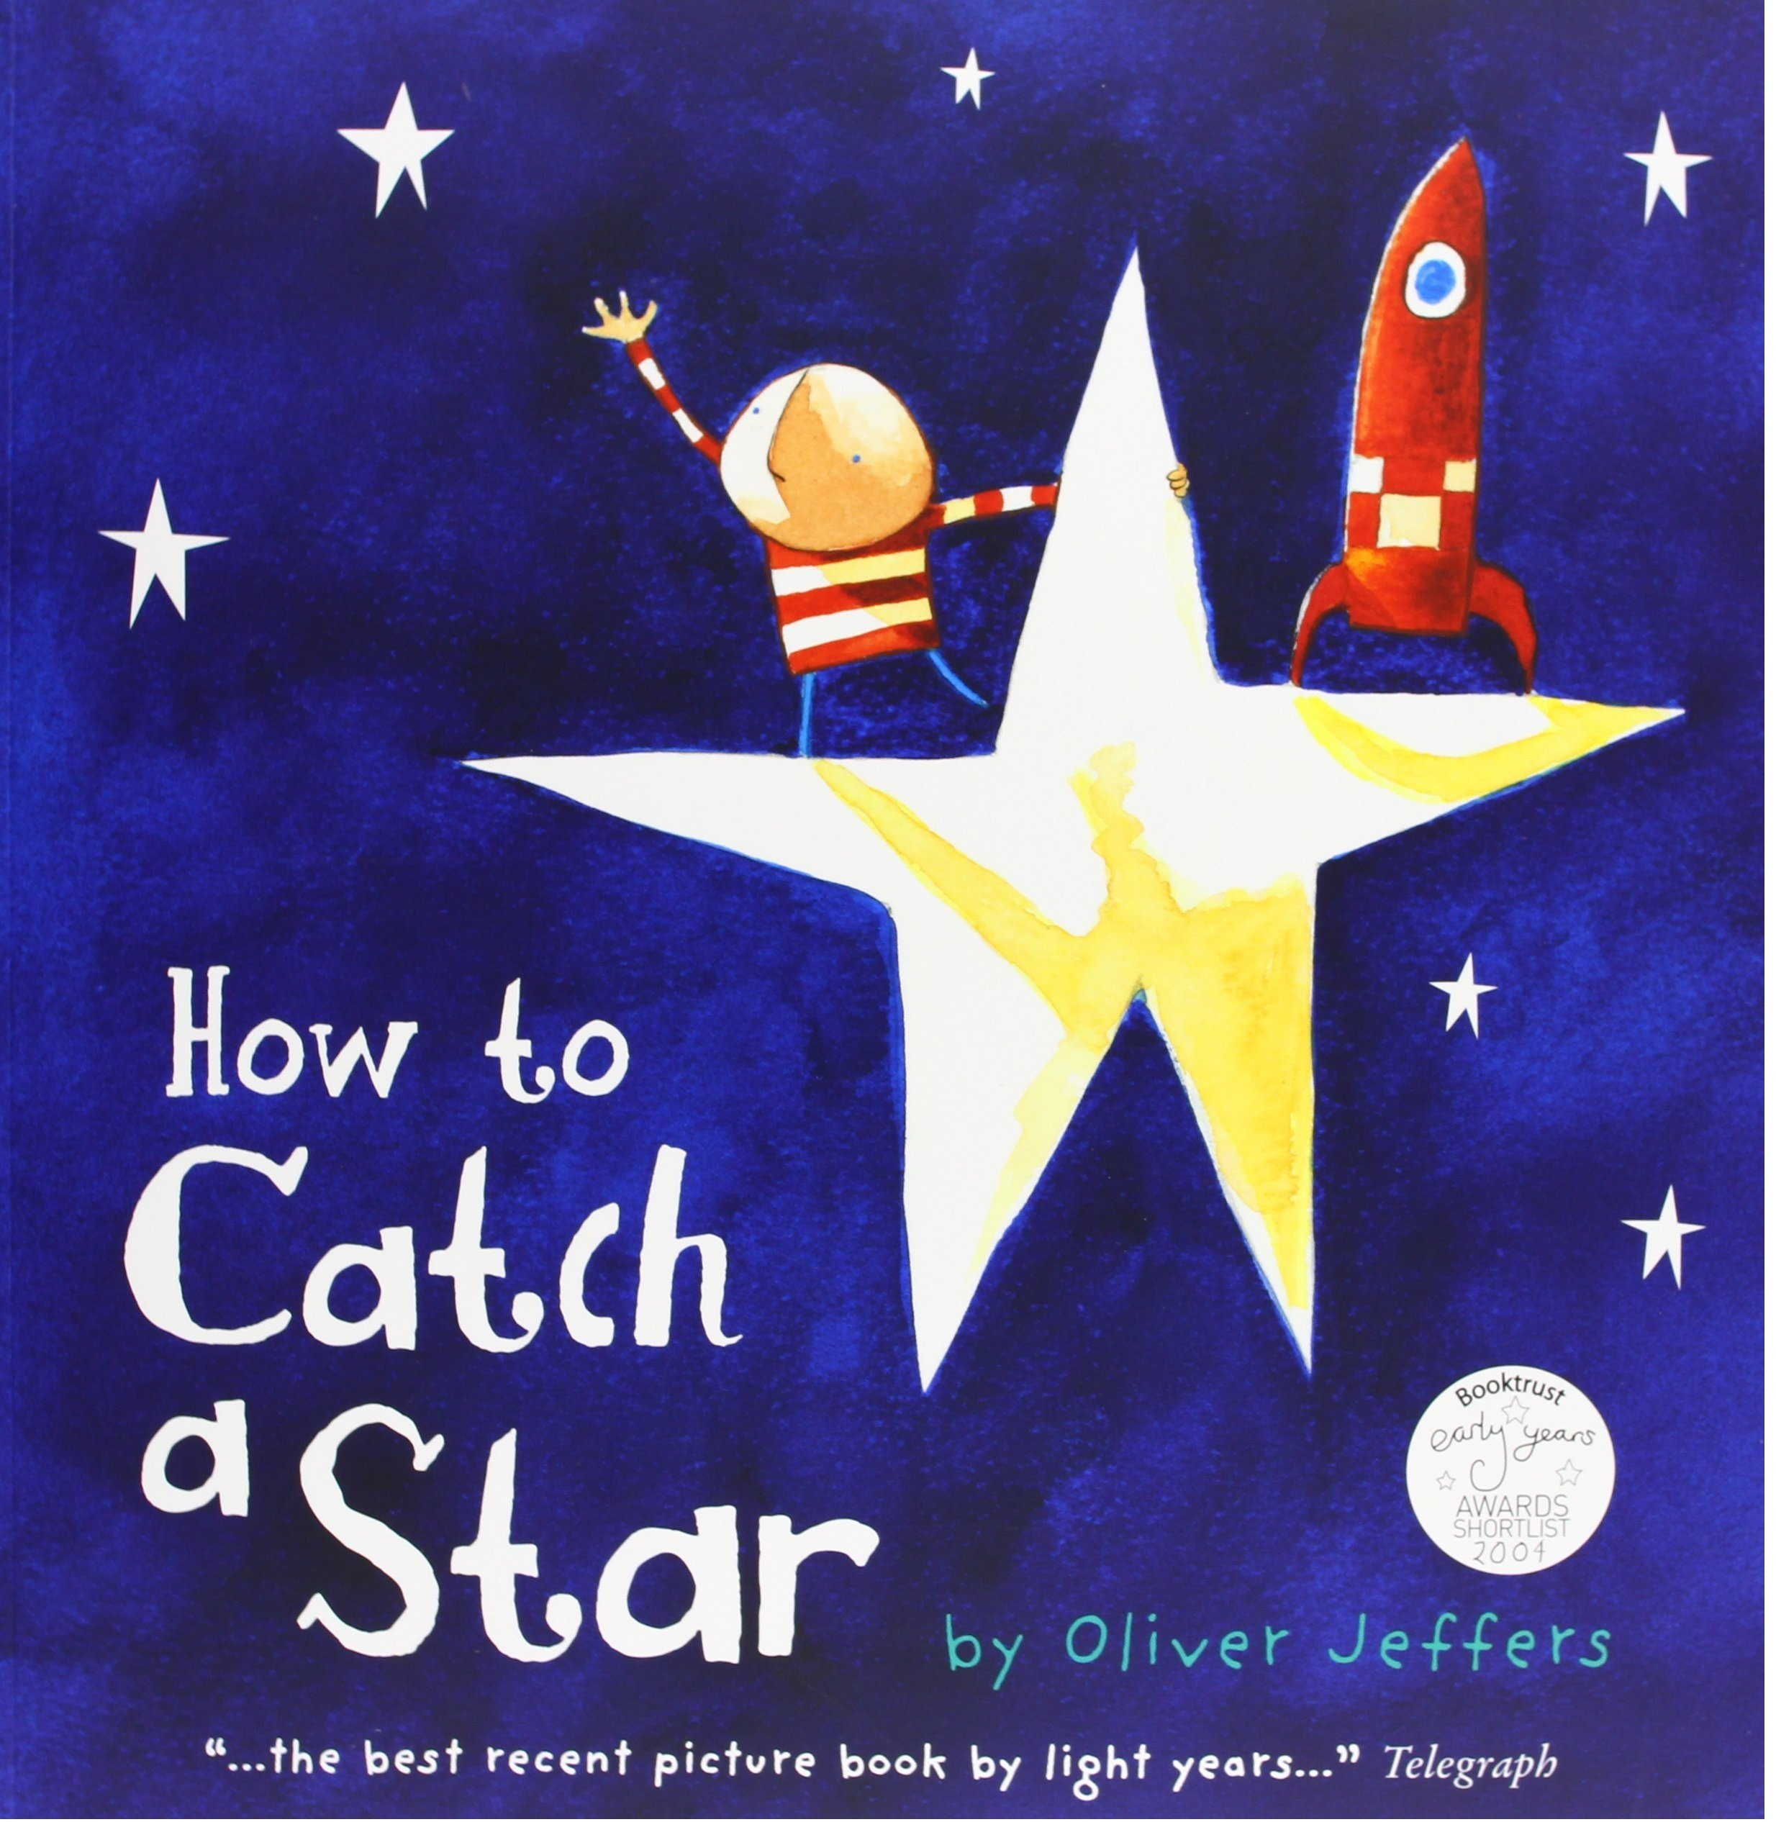  Phonics  We have started learning the phase 2 sounds during our daily phonics session. Practice singing the jolly phonic songs at home with your child, you can listen to the songs on Youtube by searching 'phase 2 jolly phonics'.  Phonics supports your child's reading and writing development. Encourage your child to write independently at home, sounding out each word, as well as looking for the sounds they can recognise when reading the home school reading book.  Homework in Reception  We give homework out every Friday and we give the children a week to complete it. All homework must be in by Friday morning.  Reading can be changed daily. Please write a comment in your child's reading record as this lets your child's class teacher know that your child has read at home.

