ADDvanced Solutions Community Network
in partnership with
THE BLACK-E
Creative arts afterschool project for children living with Neurodevelopmental conditions

On Wednesday and Friday evenings, The Black-E will be delivering an after school project to support children with Neurodevelopmental conditions, including ADHD, Autism Spectrum Disorder, Sensory Processing Difficulties and Dyspraxia etc. We aim, through lots of fun activities and our creative arts workshops to improve self-awareness, relationship development, self-confidence, self-control, improved co-ordination, social and communication skills.

Sessions on Wednesday evenings are 4.00pm until 6.00pm with an ADDvanced Solutions Community Network which includes solution focused workshops for parents and carers.

Friday evenings are drop off at 4.00pm and collect at 6.00pm children only.
You are welcome to settle in your child. These session are run term time only.
Half term creative arts activities will be advertised

To book a place, contact ADDvanced Solutions: 0151 486 1788 or email: v.reeves@addvancedsolutions.co.uk
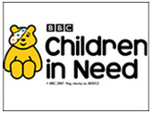
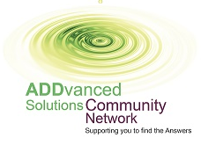

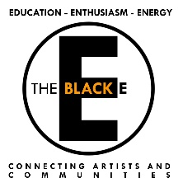
The Black-E Great George Street Liverpool L1 5EW Tel: 01517095109
Web: www.theblack-e.co.uk, Email: staff@theblack-e.co.uk

