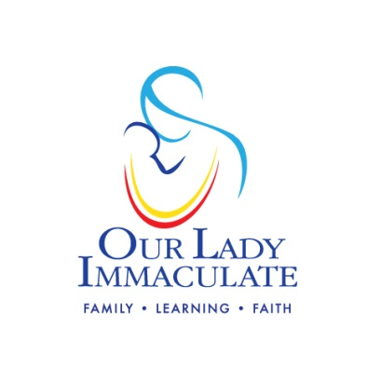

At Our Lady Immaculate Primary school we are one family living and learning in Faith and so we…

- Respect ourselves, others and our school
- Work hard at everything we do
- Do our best and never give up
- Welcome others with a smile
- Recognise achievement and celebrate success
- Show we care by listening to each other

